

***Operating Lease Support System Phase-2 Project***

***for***

****

***Functional Specification***

***FC.AB.2.1 Manage SKD***

Revision 1.0

**PT. Berlian Sistem Informasi**

KTB Annex Bld. 4th Floor, Jl. Jend. A. Yani. Pulomas,

Tel. +62 21 4786 7575 (Hunting) Fax. +62 21 4714964 www.bsi.co.id

Document Control

|  |  |
| --- | --- |
| **Author** | Raymond |
| **File Name** |  |
| **Path** |  |
| **Number of Page** |  |

Revision History

|  |  |  |  |
| --- | --- | --- | --- |
| **Date** | **Revision** | **Description** | **Author** |
| 1/10/2015 | 0.0 | Initialization | Raymond |
| 22/10/2015 | 0.1 | * Adding Functional Specification for List of Visit Customer Survey * Adding Functional Specification for Create Visit Customer Survey * Adding Functional Specification for Edit Visit Customer Survey * Adding Functional Specification for View Visit Customer Survey * Adding Functional Specification for Print Visit Customer Survey | Raymond |
| 23/11/2015 | 0.2 | * QCO review | Raymond |
| 11/12/2015 | 0.3 | * Revision of review | Raymond |
| 14/12/2015 | 1.0 | * 1st baseline | Raymond |

Distribution List

|  |  |  |
| --- | --- | --- |
| Name | Organization | Roles |
| Mr. Jin Nishimura | Dipo Star Finance, PT | DSF Project Director |
| Mr. Shinji Hosokawa | Dipo Star Finance, PT | DSF Project Advisor |
| Mr. Ahmad Fikri | Dipo Star Finance, PT | DSF Project Advisor |
| Mr. Abdul Somad | Dipo Star Finance, PT | DSF Project Manager |
| Mr. Delta Riangga | Dipo Star Finance, PT | DSF Key User |
| Mr. Mochamad Idris | Dipo Star Finance, PT | DSF Key User |
| Mrs. Herni Hembang | Dipo Star Finance, PT | DSF Key User |
| Mr. Junaidi Didy | Dipo Star Finance, PT | DSF Key User |
| Mr. Dedi Supriyadi | Dipo Star Finance,PT | DSF Key User |
| Mrs. Elke Hilviana | Dipo Star Finance,PT | DSF Key User |
| Mr. Mukhlis Ibrahim | Dipo Star Finance, PT | DSF IT Department Representative |
| Mr. Roby Wijaya | Dipo Star Finance, PT | DSF IT Department Representative |
| Mr. Daiki Kamada | Berlian Sistem Informasi, PT | BSI Project Director |
| Mr. Feri Irawan | Berlian Sistem Informasi, PT | BSI Project Advisor |
| Mr. Grand Zah Putra | Berlian Sistem Informasi, PT | BSI Project Manager |
| Mr. Raymond | Berlian Sistem Informasi, PT | BSI Business Analyst |

Document Approval

By signing this document I acknowledge I have read the document and give the Project Management Team approval to proceed.

|  |  |  |  |
| --- | --- | --- | --- |
| Role | Name | Signature | Date |
| DSF Project Director | Mr. Jin Nishimura |  |  |
| DSF Project Advisor | Mr. Ahmad Fikri |  |  |
| DSF Project Manager | Mr. Abdul Somad |  |  |
| DSF IT Department Representative | Mr. Mukhlis Ibrahim |  |  |
| BSI Project Director | Mr. Daiki Kamada |  |  |
| BSI Project Advisor | Mr. Feri Irawan |  |  |
| BSI Project Manager | Mr. Grand Zah Putra |  |  |
| BSI Business Analyst | Mr. Raymond |  |  |

Table of Contents

Document Control 2

Revision History 2

Distribution List 3

Document Approval 4

1. Introduction 6

1.1 Purpose 6

1.2 Scope 6

1.3 Definition, Acronyms, and Abbreviations 6

2.4 References 6

2. Configuration 7

3. Specification Detail: FC.AB.2.1 Manage SKD 7

3.1 Purpose 7

3.2 Screen of Configuration Access 7

3.3 Screen Functionality 7

3.4 Operation Flow 8

3.5 Screen Design 8

3.6 Component Screen Functionality 13

3.7 Operation Description 21

3.8 Data Structure 36

3.9 Screen Item List 46

3.10 Entity Relationship Diagram 59

1. Introduction
   1. Purpose

Functional Specification is a document to describe the detail of functions system which includes screen design, report, and logic formula. This document will be used for system development.

* 1. Scope

Functional Specification Document contains screen design, screen functionality, process flow, and data structure of FC.AB.2.1 Manage SKD for Phase-2

Here are the scope for FC.AB.2.1 Manage SKD:

1. **AB.2.1.3 Create SKD**

To create a SKD data

1. **AB.2.1.4 Edit SKD**

To edit a draft document of SKD

1. **AB.2.1.5 Submit SKD**

To submit SKD which will be approved by DSF Authorized Person

Output from this document is:

1. RPT.AB.2.1 SKD Form
2. PF.AB.2.1 SKD Report
   1. Definition, Acronyms, and Abbreviations
3. OPL = Operating Lease
4. DSF = Dipo Star Finance
5. BSI = Berlian Sistem Informasi
6. HOB = Head of Branch
7. HOD = Head of Department
8. RM = Regional Manager
9. SKD = Surat Keputusan Direksi/ Board of Director’s Decree
   1. References

This functional specification document refers to **“To Be Design” AB. Marketing Process**, module:

1. AB.2 SKD Process

* AB.2.1 SKD Creation of Operating Lease

1. Configuration

Here is the description of SKD Document numbering format which will be generated when PIC OPL HO/Branch clicks the Save as Draft button or Submit button on Create SKD screen.

The format of SKD Number is:

SKD Number : 0000001/4/BRANCH/MONTH/YEAR

Description :

* The first 7 digits show the sequence number of the SKD document. This number will increments whenever new SKD document is created.
* The code ‘4’, is absolute for Operating Lease (OPL).
* The code ‘BRANCH’ will be substituted by Branch/DSF Office’s code, refers to Tb\_OPL\_Branch.BranchShortName
* The code ‘MONTH’ will be substituted by 2 digits of month when the SKD document is created.
* The code ‘YEAR’ will be substituted by 4 digits of year when the SKD document is created.

1. Specification Detail: FC.AB.2.1 Manage SKD
   1. Purpose

The screens used in Manage SKD are used to Create, Edit, and Submit the SKD and generate an output as a print form of the SKD Form

* 1. Screen of Configuration Access

Here are the access right for users:

|  |  |  |  |  |
| --- | --- | --- | --- | --- |
| ***User*** | ***Create*** | ***Read*** | ***Update*** | **Authorization** |
| Marketing Officer | V | V | V | V |
| Head of Branch | - | V | - | V |
| Head of Department | - | V | - | V |
| Regional Manager | - | V | - | V |
| Advisor | - | V | - | V |
| Director | - | V | - | V |
| President Director | - | V | - | V |
| Shareholder’s Meeting | - | V | - | V |

Legend :

V = Have the Access

* 1. Screen Functionality

1. Show lists of SKD record data
2. Create a SKD
3. Edit a draft document of SKD
4. View a SKD
5. Submit a SKD
6. Print a SKD Form
   1. Operation Flow

Below is operation flow for Monitoring and print unit preparation process refer to **To Be Design Document Marketing Process**, **AB.2.1 Board of Director’s Decree/ Surat Keputusan Direksi (SKD)**:

|  |  |
| --- | --- |
| **PIC PC** | **Process** |
|  | Quotation  (OPLQuotation)  D:\Users\bsi00815\Desktop\PrintScreen\SKD\SKD v3\SKD v4\SKD_Add.png  Supplier Master Data  (Supplier)    SKD  (Tb\_MKT\_SKD)  Note:  Source  Output (Stored Data) |

* 1. Screen Design
* *Initial Screen Manage SKD*

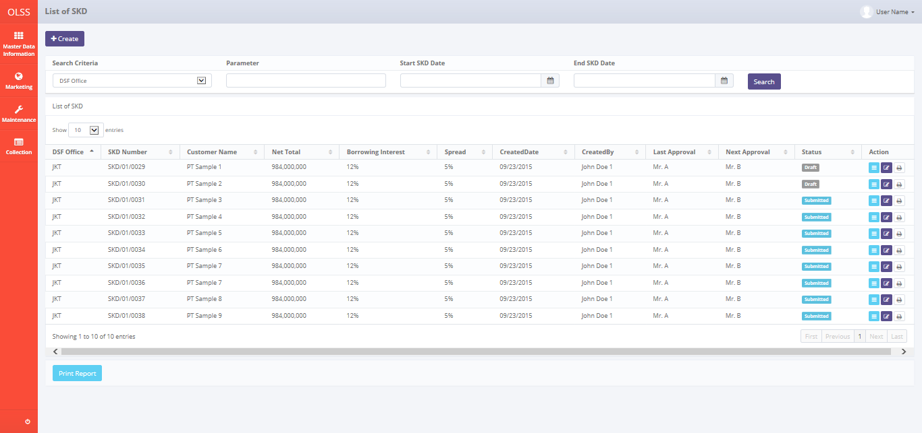

*Screen 1. List of SKD*

* *Create SKD*

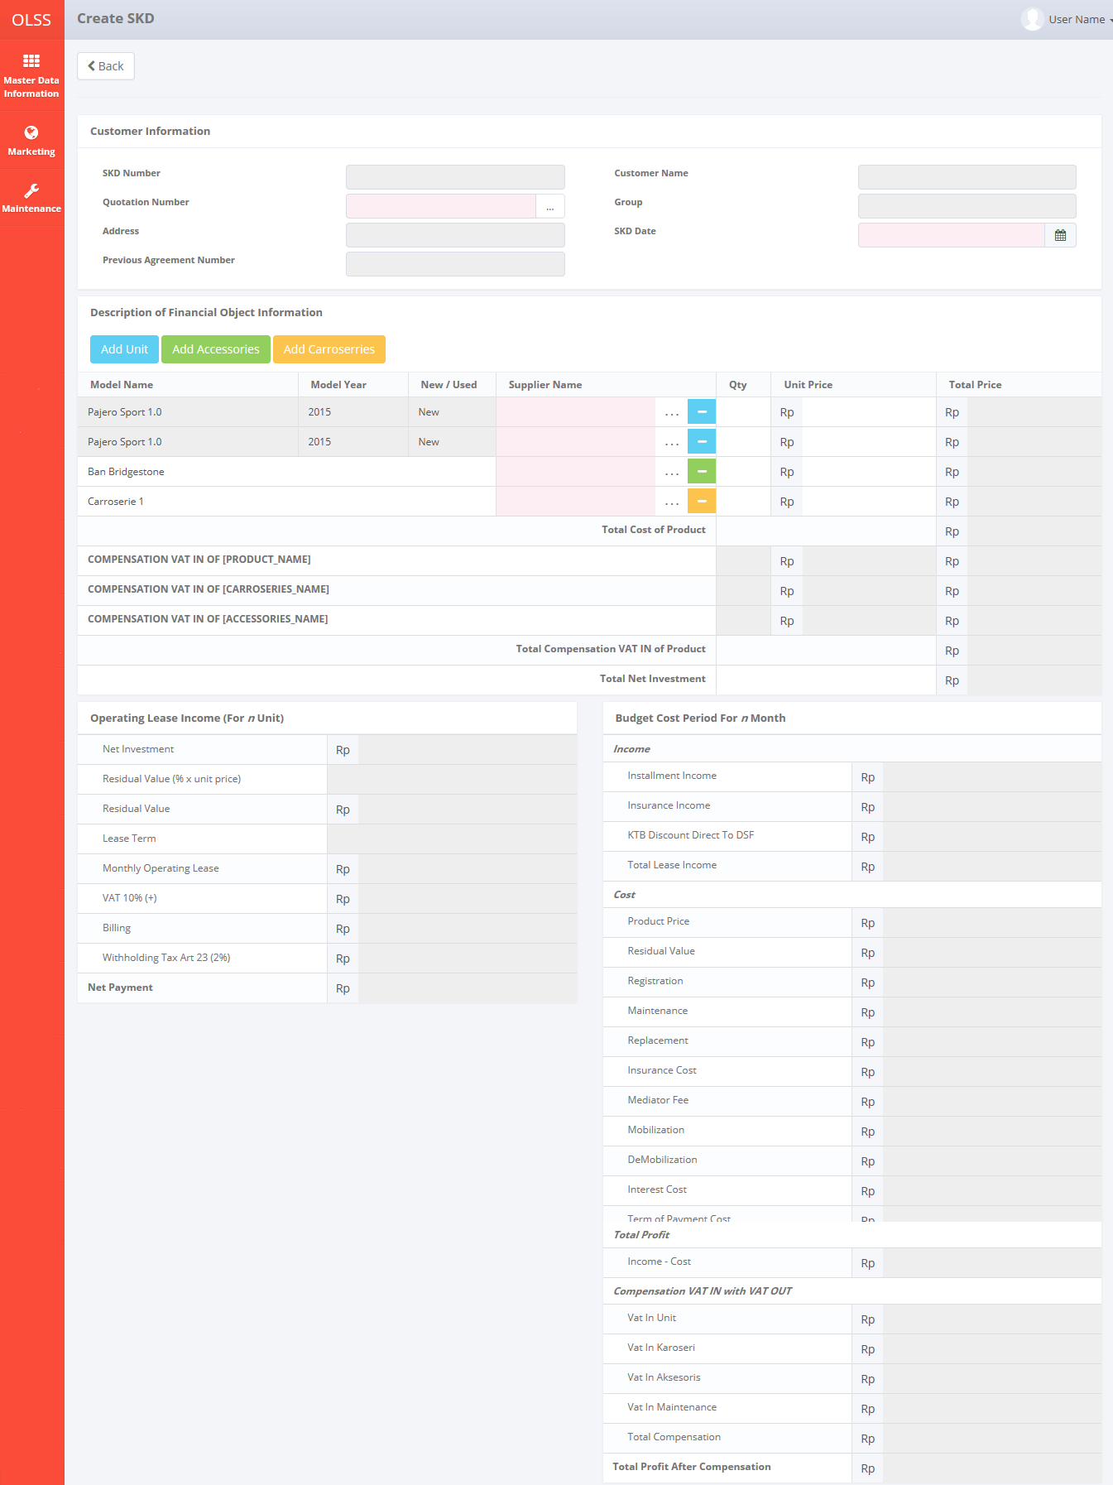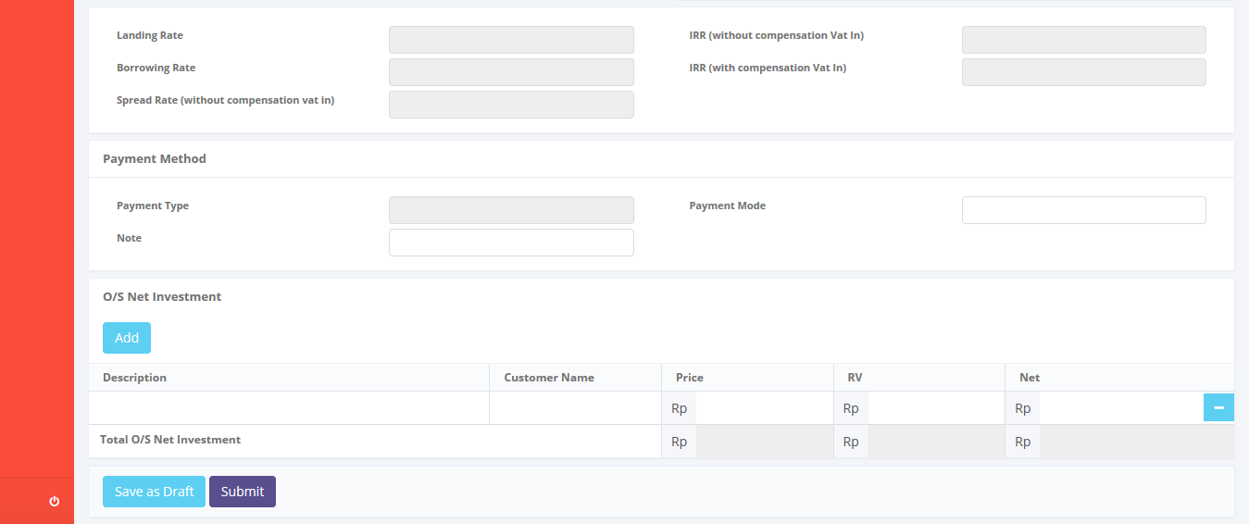

*Screen 2. Create SKD*

* *Edit SKD*

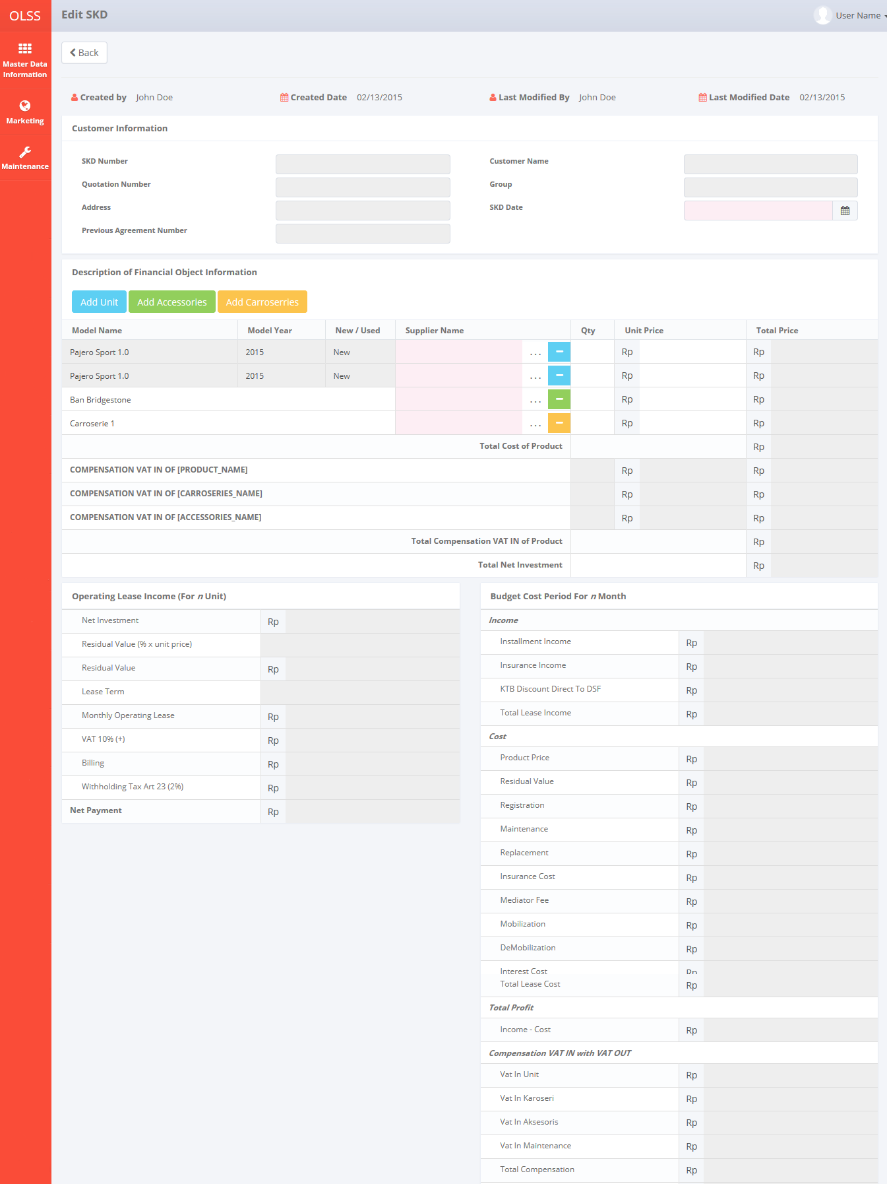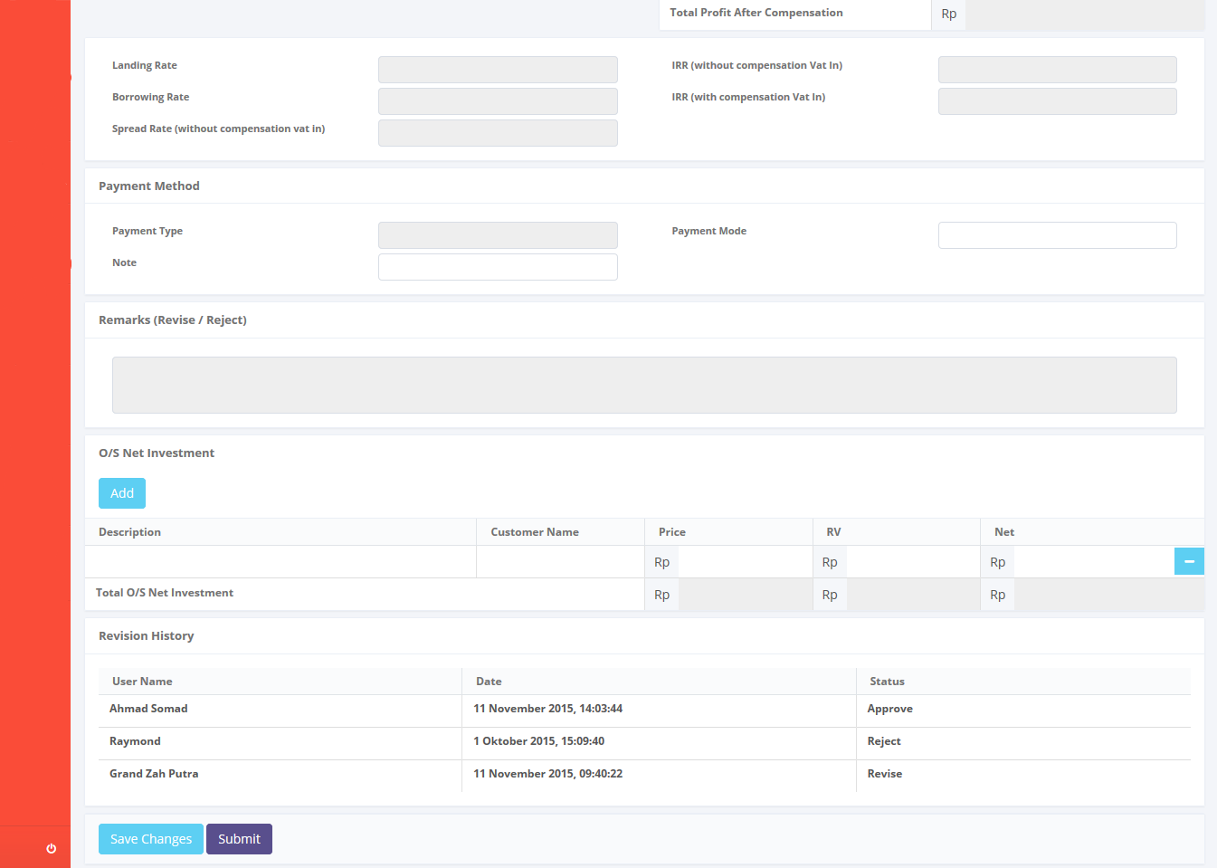

*Screen 3. Edit SKD*

* *View SKD*

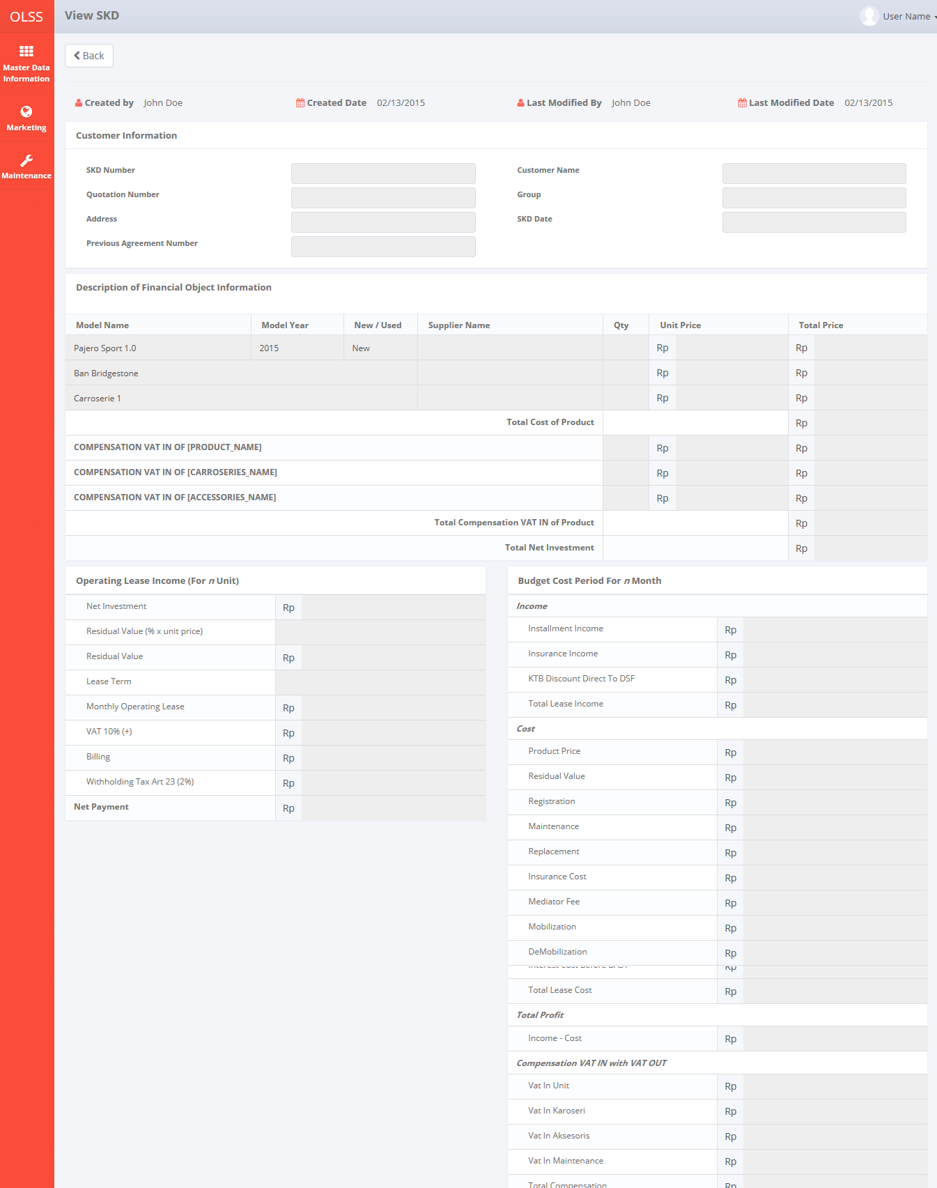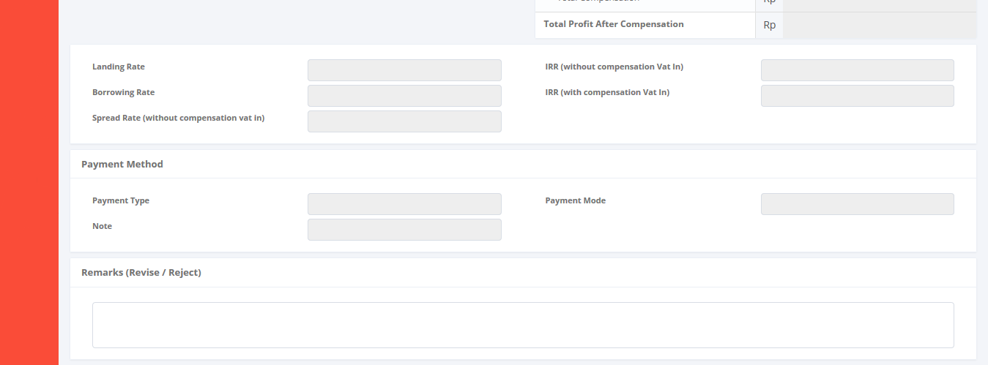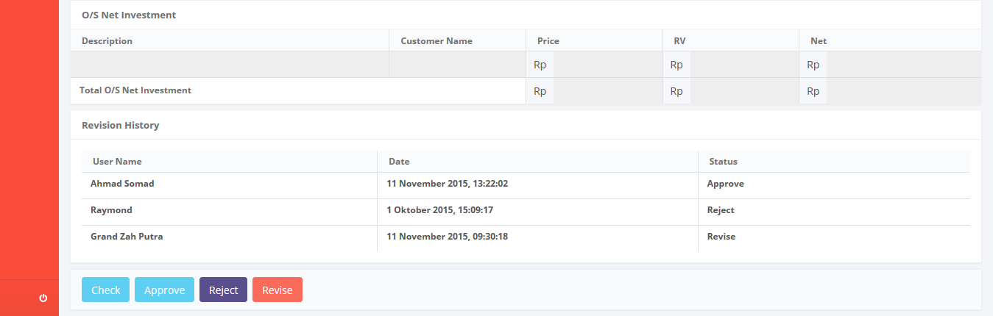

*Screen 4. View SKD*

* *Print Form SKD*

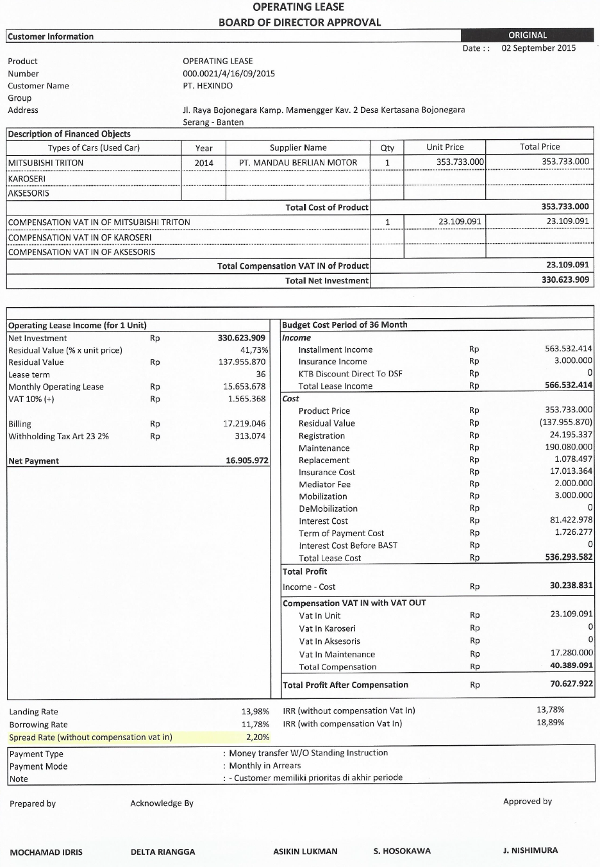

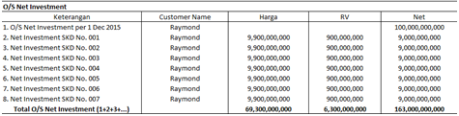

*Screen 6. Print Form SKD*

* *Notification after Save or Submit SKD*



*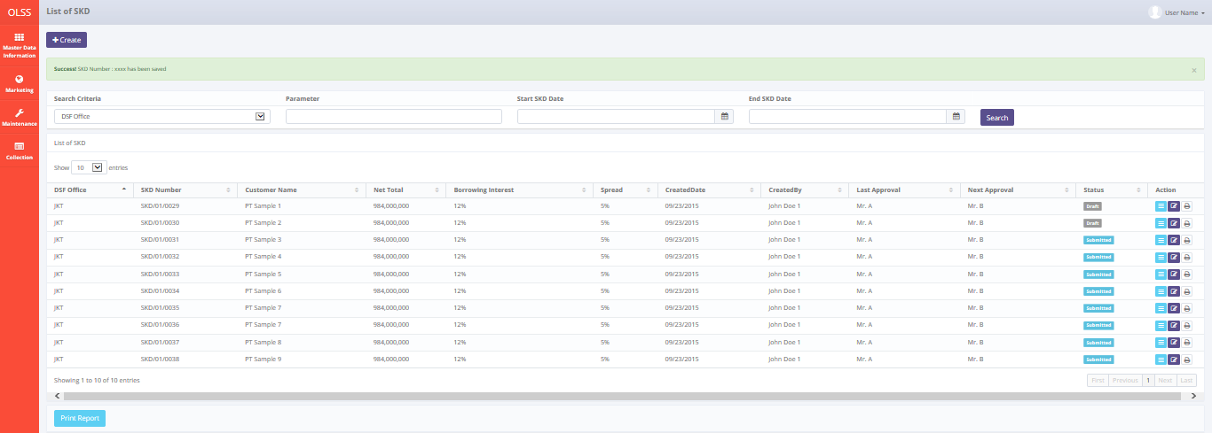*

*Screen 7. Save or Submit Notification*

* 1. Component Screen Functionality
  2. **List of SKD**

Here are the screen functions from each component in **Screen 1. List of SKD**:

|  |  |  |  |
| --- | --- | --- | --- |
| ***No*** | ***Component*** | ***Name*** | ***Function*** |
| **Header** | | | |
| 1 | Label | List of SKD | SKD Creation title |
| 2 | Button | Create SKD | To select the operation for searching |
| **Search Criteria** | | | |
| 3 | Drop down box | Search criteria | To select the category for searching criteria |
| 4 | Text Field | Parameter | To input the value for searching criteria |
| 5 | Date picker | Start SKD Date | To select the start SKD Date of record lists |
| 6 | Date picker | End SKD Date | To select the end SKD Date of record lists |
| 7 | Button | Search | To do a search and showing lists according to criteria |
| **List of SKD** | | | |
| 8 | Button | Edit SKD | To show an editable screen of Visit Customer Survey draft which has been created |
| 9 | Button | View SKD | To show details of Visit Customer Survey |
| 10 | Button | Print Form SKD | To show a preview of Visit Customer Survey report document before print |
| 11 | Drop down box | Entries | To show entry number of lists |
| 12 | Label | Customer Name | Display Customer Name of SKD that has been created |
| 13 | Button | Customer Name | To sort in ascending or descending format |
| 14 | Label | SKD Number | Display SKD Number that has been created |
| 15 | Button | SKD Number | To sort in ascending or descending format |
| 16 | Label | Net Total | Display Net Total of a SKD |
| 17 | Button | Net Total | To sort in ascending or descending format |
| 18 | Label | Borrowing Interest | Display Borrowing Interest of a SKD |
| 19 | Button | Borrowing Interest | To sort in ascending or descending format |
| 20 | Label | Created By | Display Created By of a SKD |
| 21 | Button | Created By | To sort in ascending or descending format |
| 22 | Label | Created Date | Display Created Date of a SKD |
| 23 | Button | Created Date | To sort in ascending or descending format |
| 24 | Label | Spread | Display Status of Visit Customer Survey that has been created |
| 25 | Button | Spread | To sort in ascending or descending format |
| 26 | Label | Last Approval | Display Last Approval of a SKD |
| 27 | Button | Last Approval | To sort in ascending or descending format |
| 28 | Label | Next Approval | Display Next Approval of a SKD |
| 29 | Button | Next Approval | To sort in ascending or descending format |
| 30 | Label | Action | Display Edit, View, and Report button |
| 31 | Label | Showing 1 to *n* of *n* entries | Display the entries generated by search engine |
| 32 | Link | First Page | To show the first page entry |
| 33 | Link | Previous Page | To show the previous page entry |
| 34 | Link | Page Number | To show the page screen according the number |
| 35 | Link | Next Page | To show the next page entry |
| 36 | Link | Last Page | To show the last page entry |
| **Footer** | | | |
| 37 | Button | Print Report | To print the report from the lists of record |

* 1. **Create SKD**

Here are the screen functions from each component in **Screen 2. Create SKD**:

|  |  |  |  |
| --- | --- | --- | --- |
| ***No*** | ***Component*** | ***Name*** | ***Function*** |
| **Customer Information** | | | |
| 1 | Text Field | SKD Number | Displaying SKD Number created |
| 2 | Searching Box | Quotation Number | To generate searching screen for Quotation No |
| 3 | Text Field | Address | Displaying Address value |
| 4 | Text Field | Customer Name | Displaying Customer Name value |
| 5 | Text Field | Group | Displaying Group value |
| 6 | Date Picker | SKD Date | To input SKD created date value |
| 7 | Text Field | Previous Agreement Number | Displaying Previous Agreement Number |
| **Description of Financial Object Information** | | | |
| 8 | Text Field | Model Name | Displaying Model Name |
| 9 | Text Field | Model Year | Displaying Model Year |
| 10 | Text Field | New / Used | Displaying New / Used |
| 11 | Searching Box | Supplier Name | To generate searching screen for Supplier Name |
| 12 | Button | Add Unit | To add a row of supplier for an Unit |
| 13 | Button | Add Accessories | To add a row of supplier for an Unit |
| 14 | Button | Add Carrosserie | To add a row of supplier for an Unit |
| 15 | Button | Remove | To remove a row of supplier for an item |
| 16 | Text Field | Qty | Displaying Qty |
| 17 | Text Field | Unit Price | Displaying Unit Price |
| 18 | Text Field | Total Price | Displaying Total Price |
| 19 | Text Field | Total Cost of Product | Displaying Total Cost of Product |
| 20 | Text Field | Compensation VAT IN of “Unit” | Displaying Compensation VAT IN of “Unit” |
| 21 | Text Field | Compesation VAT IN of “Carrosserie” | Displaying Compensation VAT IN of “Carrosserie” |
| 22 | Text Field | Compensation VAT IN of “Accessories” | Displaying Compensation VAT IN of “Accessories” |
| 23 | Text Field | Total Compensation VAT IN of Product | Displaying Total Compensation VAT IN of Product |
| 24 | Text Field | Total Net Investment | Displaying Total Net Investment |
| **Operating Lease Income (For *n* Unit)** | | | |
| 25 | Text Field | Net Investment | Displaying Net Investment |
| 26 | Text Field | Residual Value (% x unit price) | Displaying Residual Value (% x unit price) |
| 27 | Text Field | Residual Value | Displaying Residual Value |
| 28 | Text Field | Lease Term | Displaying Lease Term |
| 29 | Text Field | Monthly Operating Lease | Displaying Monthly Operating Lease |
| 30 | Text Field | VAT 10% (+) | Displaying VAT 10% (+) |
| 31 | Text Field | Billing | Displaying Billing |
| 32 | Text Field | Witholding Tax Art 23 (2%) | Displaying Witholding Tax Art 23 (2%) |
| 33 | Text Field | Net Payment | Displaying Net Payment |
| **Budget Cost Period For *n* Month** | | | |
| 34 | Label | Income | Displaying Income label |
| 35 | Text Field | Installment Income | Displaying Installment Income |
| 36 | Label | Insurance Income | Displaying Budget Cost Period For n Month label |
| 37 | Text Field | KTB Discount Direct To DSF | Displaying KTB Discount Direct To DSF |
| 38 | Text Field | Total Lease Income | Displaying Total Lease Income |
| 39 | Label | Cost | Displaying Cost label |
| 40 | Text Field | Product Price | Displaying Product Price |
| 41 | Text Field | Residual | Displaying Residual |
| 42 | Text Field | Registration | Displaying Registration |
| 43 | Text Field | Maintenance | Displaying Maintenance |
| 44 | Text Field | Replacement | Displaying Replacement |
| 45 | Text Field | Insurance Cost | Displaying Insurance Cost |
| 46 | Text Field | Mediator Fee | Displaying Mediator Fee |
| 47 | Text Field | Mobilization | Displaying Mobilization |
| 48 | Text Field | DeMobilization | Displaying DeMobilization |
| 49 | Text Field | Interest Cost | Displaying Interest Cost |
| 50 | Text Field | Term of Payment Cost | Displaying Term of Payment Cost |
| 51 | Text Field | Interest Cost Before BAST | Displaying Interest Cost Before BAST |
| 52 | Text Field | Total Lease Cost | Displaying Total Lease Cost |
| 53 | Label | Total Profit | Displaying Total Profit label |
| 54 | Text Field | Income - Cost | Displaying Income - Cost |
| 55 | Label | Compensation VAT IN with VAT OUT | Displaying Compensation VAT IN with VAT OUT label |
| 56 | Text Field | Vat In Unit | Displaying Vat In Unit |
| 57 | Text Field | VAT In Carrosserie | Displaying VAT In Carrosserie |
| 58 | Text Field | VAT In Accessories | Displaying VAT In Accessories |
| 59 | Text Field | VAT In Maintenance | Displaying VAT In Maintenance |
| 60 | Text Field | Total Compensation | Displaying Total Compensation |
| 61 | Text Field | Total Profit After Compensation | Displaying Total Profit After Compensation |
| 62 | Text Field | Landing Rate | Displaying Landing Rate |
| 63 | Text Field | Borrowing Rate | Displaying Borrowing Rate |
| 64 | Text Field | Spread Rate (without compensation vat in) | Displaying Spread Rate (without compensation vat in) |
| 65 | Text Field | IRR (without compensation Vat In) | Displaying IRR (without compensation Vat In) |
| 66 | Text Field | IRR (with compensation Vat In) | Displaying IRR (with compensation Vat In) |
| **Payment Method** | | | |
| 67 | Text Field | Payment Type | To input Payment Type |
| 68 | Text Field | Payment Mode | Displaying Payment Mode |
| 69 | Text Area | Notes | To input Notes |
| **O/S Net Investment** | | | |
| 70 | Button | Add | To add a Net Investment data row |
| 71 | Button | Remove | To remove a Net Investment data row |
| 72 | Text Field | Description | To show the Description of SKD Net Investment data row |
| 73 | Text Field | Customer Name | To show Customer Name of the SKD Data in description |
| 74 | Text Field | Price | To show Price of the SKD Data in description |
| 75 | Text Field | RV | To show RV of the SKD Data in description |
| 76 | Text Field | Net | To show Net of the SKD Data in description |
| 77 | Text Field | Total O/S Net Investment for Price, RV, and Net | Total amount of Price, RV, and Net |
| **Footer** | | | |
| 78 | Button | Save as Draft | To save information that has been inserted at SKD form as a draft |
| 79 | Button | Submit | To submit information that has been inserted at SKD form to the next level |

* 1. **Edit SKD**

Here are the screen functions from each component in **Screen 3. Edit SKD**:

*See Component Screen Specification - b. Create SKD with addition of these components :*

|  |  |  |  |
| --- | --- | --- | --- |
| ***No*** | ***Component*** | ***Name*** | ***Function*** |
| **Header** | | | |
| 1 | Label | Edit SKD | Edit SKD title |
| 2 | Label | Created By | Displaying Created By |
| 3 | Label | Created Date | Displaying Created Date |
| 4 | Label | Last Modified By | Displaying Last Modified By |
| 5 | Label | Last Modified Date | Displaying Last Modified Date |
| **Customer Information** | | | |
| 6 | Text Field | Quotation Number | Displaying Quotation Number |
| **Revision History** | | | |
| 7 | Label | Revision History | Revision History sub-title |
| 8 | Label | User Name | Displaying User Name |
| 9 | Label | Date | Displaying Date |
| 10 | Label | Status | Displaying Status |
| **Footer** | | | |
| 11 | Text Area | Remarks (Reject/ Revise) | Displaying remarks from rejection/ revision |
| 12 | Button | Save Changes | To save the inputted form as draft document |

*and also these components are not available in Edit SKD :*

|  |  |  |  |
| --- | --- | --- | --- |
| ***No*** | ***Component*** | ***Name*** | ***Function*** |
| **Header** | | | |
| 1 | Label | Create SKD | Create SKD title |
| **Footer** | | | |
| 2 | Button | Save as Draft | To save the inputted form as draft document |

* 1. **View SKD**

Here are the screen functions from each component in **Screen 4. View SKD**:

*See Component Screen Specification - b. Create SKD with addition of these components :*

|  |  |  |  |
| --- | --- | --- | --- |
| ***No*** | ***Component*** | ***Name*** | ***Function*** |
| **Header** | | | |
| 1 | Label | View SKD | View SKD title |
| 2 | Label | Created By | Displaying Created By |
| 3 | Label | Created Date | Displaying Created Date |
| 4 | Label | Last Modified By | Displaying Last Modified By |
| 5 | Label | Last Modified Date | Displaying Last Modified Date |
| **Customer Information** | | | |
| 6 | Text Field | Quotation Number | Displaying Quotation Number |
| **Revision History** | | | |
| 7 | Label | Revision History | Revision History sub-title |
| 8 | Label | User Name | Displaying User Name |
| 9 | Label | Date | Displaying Date |
| 10 | Label | Status | Displaying Status |
| **Footer** | | | |
| 11 | Text Area | Remarks (Reject/ Revise) | To input remarks of revision or rejection |
| 12 | Button | Check | To check a SKD |
| 13 | Button | Approve | To approve a SKD |
| 14 | Button | Reject | To reject a SKD |
| 15 | Button | Revise | To revise a SKD |

*and also these components are not available in View SKD :*

|  |  |  |  |
| --- | --- | --- | --- |
| ***No*** | ***Component*** | ***Name*** | ***Function*** |
| **Header** | | | |
| 1 | Label | Create SKD | Create SKD title |
| **Description of Financial Object Information** | | | |
| 2 | Button | Add Unit | To add a row of supplier for an Unit |
| 3 | Button | Add Accessories | To add a row of supplier for an Unit |
| 4 | Button | Add Carrosserie | To add a row of supplier for an Unit |
| 5 | Button | Remove | To remove a row of supplier for an item |
| **O/S Net Investment** | | | |
| 6 | Button | Add | To add a Net Investment data row |
| 7 | Button | Remove | To remove a Net Investment data row |
| **Footer** | | | |
| 8 | Button | Save as Draft | To save the inputted form as draft document |
| 9 | Button | Submit | To submit the inputted form |

* 1. **Print Form SKD**

Here are the screen functions from each component in **Screen 5. Print Form SKD**:

|  |  |  |  |
| --- | --- | --- | --- |
| ***No*** | ***Component*** | ***Name*** | ***Function*** |
| **Header** | | | |
| 1 | Label | Print SKD | Print SKD title |
| 2 | Button | Back | Back to previous screen |
| 3 | Button | Print | To print the previewed document |
| 4 | Link | First Page | To show the first page |
| 5 | Link | Previous Page | To show the previous page |
| 6 | Text Field | Page Number | To show the page screen according to the number |
| 7 | Link | Next Page | To show the next page |
| 8 | Link | Last Page | To show the last page |
| 9 | Text Field | Search field | To input the keyword to be searched in the form page |
| 10 | Link | Find | To find the keyword in the search field |
| 11 | Link | Next | To move to the nect keyword found on the form page |
| 12 | Drop down box | Convert to excel/ pdf | To convert the document into excel/ pdf |
| 13 | Button | Refresh | To refresh the page |
| **Body page** | | | |
| 14 | Image preview | SKD Form | Displaying the preview of document |

* 1. Operation Description

|  |  |  |
| --- | --- | --- |
| **No.** | **Operation Name** | **Description** |
| 1 | Initial view of List of SKD | The screen for list of SKD:   1. Component Status;  |  |  |  |  | | --- | --- | --- | --- | | Component | Name/Caption | Status | Remark | | Label | List of SKD | Not Active |  | | Button | Create SKD | Active |  | | Drop down box | Search criteria | Active |  | | Text Field | Parameter | Active |  | | Date picker | Start SKD Date | Active | *Format: ”MM/dd/yyyy”* | | Date picker | End SKD Date | Active | *Format: ”MM/dd/yyyy”* | | Button | Search | Active |  | | Button | Edit SKD | Active |  | | Button | View SKD | Active |  | | Button | Print Form SKD | Active |  | | Drop down box | Entries | Active |  | | Label | Customer Name | Not Active |  | | Button | Customer Name | Active |  | | Label | SKD Number | Not Active |  | | Button | SKD Number | Active |  | | Label | Net Total | Not Active |  | | Button | Net Total | Active |  | | Label | Borrowing Interest | Not Active |  | | Button | Borrowing Interest | Active |  | | Label | Created By | Not Active |  | | Button | Created By | Active |  | | Label | Created Date | Not Active | *Format: ”MM/dd/yyyy”* | | Button | Created Date | Active |  | | Label | Spread | Not Active |  | | Button | Spread | Active |  | | Label | Last Approval | Active |  | | Button | Last Approval | Active |  | | Label | Next Approval | Active |  | | Button | Next Approval | Active |  | | Label | Action | Not Active |  | | Label | Showing 1 to *n* of *n* entries |  |  | | Link | First Page | Active | Active depending on the current entry | | Link | Previous Page | Active | Active depending on the current entry | | Link | Page Number | Active | Active depending on the current entry | | Link | Next Page | Active | Active depending on the current entry | | Link | Last Page | Active | Active depending on the current entry | | Button | Print Report | Active |  | |
| 2 | Searching the List of SKD | Input:   1. Select searching criteria category (search criteria), searching criteria value (parameter), Start SKD Date, and End SKD Date in the Search Field     Constraint:   1. Search criteria only consists of SKD Number, Customer Name, Net Total, Borrowing Interest, Spread, Last Approval, Next Approval, and Status (the same as the lists) generated from Tb\_OPL\_SearchCriteria mapping 2. End SKD Date can not be less than Start SKD Date (the End SKD Date will be locked for the date before Start SKD Date) 3. Start SKD Date can not be less than End SKD Date (the Start SKD Date will be locked for the date after End SKD Date) 4. Click on the Search button   D:\Users\bsi00815\AppData\Local\Microsoft\Windows\Temporary Internet Files\Content.Word\Visit Customer Survey Report.png   1. The screen will view the list of SKD according to criteria   Process:   1. After clicking the search button, the system will get the data from Tb\_MKT\_SKD table, OPLCalculation table, and CashflowSummary table to be displayed in the list 2. System will display error notification, when:   - If data that will be search is not available then system will display notification “Data not found”  - If parameter input is not match with input constraint in data structure then system will display notification “Parameter is not valid”   1. The data displayed will be sorted based on CreatedDate in descending   Output:   1. Display list data of SKD   Alternative :   1. Select number of show list entries: 10, 25, 50, and 100 and click the page for viewing more data   **NB:The approval status can be monitored by seeing the last approval and next approval column. User with his/her name attached in last approval column is the latest person to approve and user with his/her name attached in next approval column is the next person to approve the document. This also apply for Check process (*refer to FC.AB.2.2 Approval SKD*)** |
| 3 | Initial view of Create SKD | The screen for Create SKD:   1. Status component;  |  |  |  |  | | --- | --- | --- | --- | | Component | Name/Caption | Status | Remark | | Label | Create SKD |  |  | | Text Field | SKD Number | Not Active |  | | Searching Box | Quotation Number | Active | Mandatory field depicted in red Text Field | | Text Field | Address | Not Active |  | | Text Field | Customer Name | Not Active |  | | Text Field | Group | Not Active |  | | Date Picker | SKD Date | Active | Mandatory field depicted in red Text Field  *Format: ”MM/dd/yyyy”* | | Text Field | Previous Agreement Number | Not Active |  | | Text Field | Model Name | Not Active |  | | Text Field | Model Year | Not Active |  | | Text Field | New / Used | Not Active |  | | Searching Box | Supplier Name | Active | Mandatory field depicted in red Text Field | | Button | Add Unit | Active |  | | Button | Add Accessories | Active |  | | Button | Add Carrosserie | Active |  | | Button | Remove | Active |  | | Text Field | Qty | Active |  | | Text Field | Unit Price | Active | Not active for “Unit” and Compensation VAT IN | | Text Field | Total Price | Not Active |  | | Text Field | Total Cost of Product | Not Active |  | | Text Field | Compensation VAT IN of “Unit” | Not Active |  | | Text Field | Compesation VAT IN of “Carrosserie” | Not Active |  | | Text Field | Compensation VAT IN of “Accessories” | Not Active |  | | Text Field | Total Compensation VAT IN of Product | Not Active |  | | Text Field | Total Net Investment | Not Active |  | | Text Field | Net Investment | Not Active |  | | Text Field | Residual Value (% x unit price) | Not Active |  | | Text Field | Residual Value | Not Active |  | | Text Field | Lease Term | Not Active |  | | Text Field | Monthly Operating Lease | Not Active |  | | Text Field | VAT 10% (+) | Not Active |  | | Text Field | Billing | Not Active |  | | Text Field | Witholding Tax Art 23 (2%) | Not Active |  | | Text Field | Net Payment | Not Active |  | | Label | Income | Not Active |  | | Text Field | Installment Income | Not Active |  | | Label | Insurance Income | Not Active |  | | Text Field | KTB Discount Direct To DSF | Not Active |  | | Text Field | Total Lease Income | Not Active |  | | Label | Cost | Not Active |  | | Text Field | Product Price | Not Active |  | | Text Field | Residual | Not Active |  | | Text Field | Registration | Not Active |  | | Text Field | Maintenance | Not Active |  | | Text Field | Replacement | Not Active |  | | Text Field | Insurance Cost | Not Active |  | | Text Field | Mediator Fee | Not Active |  | | Text Field | Mobilization | Not Active |  | | Text Field | DeMobilization | Not Active |  | | Text Field | Interest Cost | Not Active |  | | Text Field | Term of Payment Cost | Not Active |  | | Text Field | Interest Cost Before BAST | Not Active |  | | Text Field | Total Lease Cost | Not Active |  | | Label | Total Profit | Not Active |  | | Text Field | Income - Cost | Not Active |  | | Label | Compensation VAT IN with VAT OUT | Not Active |  | | Text Field | Vat In Unit | Not Active |  | | Text Field | VAT In Carrosserie | Not Active |  | | Text Field | VAT In Accessories | Not Active |  | | Text Field | VAT In Maintenance | Not Active |  | | Text Field | Total Compensation | Not Active |  | | Text Field | Total Profit After Compensation | Not Active |  | | Text Field | Landing Rate | Not Active |  | | Text Field | Borrowing Rate | Not Active |  | | Text Field | Spread Rate (without compensation vat in) | Not Active |  | | Text Field | IRR (without compensation Vat In) | Not Active |  | | Text Field | IRR (with compensation Vat In) | Not Active |  | | Text Field | Payment Type | Not Active |  | | Text Field | Payment Mode | Active |  | | Text Field | Notes | Active |  | | Button | Add | Active |  | | Button | Remove | Active |  | | Text Field | Description | Active |  | | Text Field | Customer Name | Active |  | | Text Field | Price | Active |  | | Text Field | RV | Active |  | | Text Field | Net | Not Active |  | | Text Field | Total O/S Net Investment for Price, RV, and Net |  |  | | Button | Save as Draft | Active |  | | Button | Submit | Active |  | |
| 4 | Create SKD | Input   1. Click the button Create SKD on the List of SKD screen      1. Input the following field:  * Quotation No * SKD Date * Model Name Unit * Model Name Carrosserie * Model Name Accessories * Supplier Name * Qty * Unit Price Carroserrie * Unit Price Accessories * Payment Mode * Notes * O/S Investment   Constraints:   1. Inputting Qty will trigger a hint to input the field with only number 2. Hint “24 hours format” will appear if the user clicked onto the field SKD Date 3. Every field inputted cannot exceed maximum length defined in database structure system 4. If there are cases which require multiple supplier to provide the item, it is possible to Add Unit, Carrosserie, and Accessories and define the qty needed for the supplier to provide 5. The Quantity for compensation of VAT IN for Unit,Carrosserrie, and Accessories will follow the quantity (Qty) of the correspondent item 6. An autocomplete will appear when inputting Accessories or Carrosserie Name. The name will be distincted from Tb\_MKT\_SKD\_Dtl.Name 7. Addition of Supplier of Unit, Accessories details, and Carroserrie details can be done by clicking Add button for each corresponding item. Remove button for deleting each corresponding item. 8. From step 2, click on Save as Draft button to save the document in draft status   D:\Users\bsi00815\AppData\Local\Microsoft\Windows\Temporary Internet Files\Content.Word\VCS_Create.png  Constraint:   1. Clicking the button will trigger a pop up screen for validation “**Are you sure you want to Save?**”   D:\Users\bsi00815\Downloads\saveconfirmation.JPG   1. If “Yes” is clicked (pop up screen) with any of the field still hasn’t meet the validation criteria, every notification message for validation below the field will be generated (notification “This field is required” for mandatory field) 2. A validation will appear after clicking “Yes” of confirmation for total Qty of Accessories and Carrosserie in which Qty of one type of Accessories or Qty of one type of Carrosserie cannot exceed the total Qty of Unit (ex: If Unit Qty = 5, then Accessories Qty <= 5 for each type of Accessories, and also Carrosserie Qty <= 5 for each type of Carrosserie) 3. From step 2, click on Submit button to submit the document for next process and change the status of document into Submitted   D:\Users\bsi00815\AppData\Local\Microsoft\Windows\Temporary Internet Files\Content.Word\VCS_Edit.png  Constraint:   1. Clicking the button will trigger a pop up screen for validation “**Are you sure you want to Submit?**”   D:\Users\bsi00815\Downloads\submitconfirmation (1).JPG   1. If “Yes” is clicked (pop up screen) with any of the field still hasn’t meet the validation criteria, every notification message for validation below the field will be generated (notification “This field is required” for mandatory field) 2. A validation will appear after clicking “Yes” of confirmation for total Qty of Accessories and Carrosserie in which Qty of one type of Accessories or Qty of one type of Carrosserie cannot exceed the total Qty of Unit (ex: If Unit Qty = 5, then Accessories Qty <= 5 for each type of Accessories, and also Carrosserie Qty <= 5 for each type of Carrosserie)   Process:   1. Inputting Quotation No will get data for all Entity (except SKD Date, Supplier Name, Quantity, and Notes) from Tb\_MKT\_OPLCalculation 2. Qty of Accessories and Carroserrie as part of item attached to unit will follow the qty of the unit itself 3. Formulation will auto calculate in the form for each input that affect the formula (**refer to 3.8 data structure**) 4. Revision Log will be inserted with the User Name, Date, and Status of the last activity into Tb\_MKT\_SKD\_History   Status consists of:   * Update (when button Save as Draft or Save Changes is clicked) * Submit (when button Submit is clicked) * Check (when button Check is clicked) * Approve (when button Approve is clicked) * Reject (when button Reject is clicked) * Revise (when button Revise is clicked)  1. O/S Net Investment initially will be inserted with Price (Net after VAT) of current product, Residual Value (Residual Value) of current product, and Net Investment (Net after VAT – Residual Value) of current product   Output:   1. By clicking save as draft or submit, the inputted data will be inserted into Tb\_MKT\_SKD table and generate SKD Number with a notification “**Success!** SKD Number : xxxx has been saved” (xxxx refers to Tb\_MKT\_SKD.SKDNo)   Altenative:   1. From step 1, click on Back button to go back to previous menu (List of SKD) |
| 5 | Initial view of Edit SKD | The screen for Edit SKD:   1. Status component;  |  |  |  |  | | --- | --- | --- | --- | | Component | Name/Caption | Status | Remark | | Label | Edit SKD | Not Active |  | | Label | Created By | Not Active |  | | Label | Created Date | Not Active |  | | Label | Last Modified By | Not Active |  | | Label | Last Modified Date | Not Active |  | | Text Field | SKD Number | Not Active |  | | Searching Box | Quotation Number | Active | Mandatory field depicted in red Text Field | | Text Field | Address | Not Active |  | | Text Field | Customer Name | Not Active |  | | Text Field | Group | Not Active |  | | Date Picker | SKD Date | Active | Mandatory field depicted in red Text Field  *Format: ”MM/dd/yyyy”* | | Text Field | Previous Agreement Number | Not Active |  | | Text Field | Model Name | Not Active |  | | Text Field | Model Year | Not Active |  | | Text Field | New / Used | Not Active |  | | Searching Box | Supplier Name | Active | Mandatory field depicted in red Text Field | | Button | Add Unit | Active |  | | Button | Add Accessories | Active |  | | Button | Add Carrosserie | Active |  | | Button | Remove | Active |  | | Text Field | Qty | Active |  | | Text Field | Unit Price | Active | Not active for “Unit” and Compensation VAT IN | | Text Field | Total Price | Not Active |  | | Text Field | Total Cost of Product | Not Active |  | | Text Field | Compensation VAT IN of “Unit” | Not Active |  | | Text Field | Compesation VAT IN of “Carrosserie” | Not Active |  | | Text Field | Compensation VAT IN of “Accessories” | Not Active |  | | Text Field | Total Compensation VAT IN of Product | Not Active |  | | Text Field | Total Net Investment | Not Active |  | | Text Field | Net Investment | Not Active |  | | Text Field | Residual Value (% x unit price) | Not Active |  | | Text Field | Residual Value | Not Active |  | | Text Field | Lease Term | Not Active |  | | Text Field | Monthly Operating Lease | Not Active |  | | Text Field | VAT 10% (+) | Not Active |  | | Text Field | Billing | Not Active |  | | Text Field | Witholding Tax Art 23 (2%) | Not Active |  | | Text Field | Net Payment | Not Active |  | | Label | Income | Not Active |  | | Text Field | Installment Income | Not Active |  | | Label | Insurance Income | Not Active |  | | Text Field | KTB Discount Direct To DSF | Not Active |  | | Text Field | Total Lease Income | Not Active |  | | Label | Cost | Not Active |  | | Text Field | Product Price | Not Active |  | | Text Field | Residual | Not Active |  | | Text Field | Registration | Not Active |  | | Text Field | Maintenance | Not Active |  | | Text Field | Replacement | Not Active |  | | Text Field | Insurance Cost | Not Active |  | | Text Field | Mediator Fee | Not Active |  | | Text Field | Mobilization | Not Active |  | | Text Field | DeMobilization | Not Active |  | | Text Field | Interest Cost | Not Active |  | | Text Field | Term of Payment Cost | Not Active |  | | Text Field | Interest Cost Before BAST | Not Active |  | | Text Field | Total Lease Cost | Not Active |  | | Label | Total Profit | Not Active |  | | Text Field | Income - Cost | Not Active |  | | Label | Compensation VAT IN with VAT OUT | Not Active |  | | Text Field | Vat In Unit | Not Active |  | | Text Field | VAT In Carrosserie | Not Active |  | | Text Field | VAT In Accessories | Not Active |  | | Text Field | VAT In Maintenance | Not Active |  | | Text Field | Total Compensation | Not Active |  | | Text Field | Total Profit After Compensation | Not Active |  | | Text Field | Landing Rate | Not Active |  | | Text Field | Borrowing Rate | Not Active |  | | Text Field | Spread Rate (without compensation vat in) | Not Active |  | | Text Field | IRR (without compensation Vat In) | Not Active |  | | Text Field | IRR (with compensation Vat In) | Not Active |  | | Text Field | Payment Type | Not Active |  | | Text Field | Payment Mode | Active |  | | Text Field | Notes | Active |  | | Text Area | Remarks (Reject / Revise) | Not Active |  | | Button | Add | Active |  | | Button | Remove | Active |  | | Text Field | Description | Active |  | | Text Field | Customer Name | Active |  | | Text Field | Price | Active |  | | Text Field | RV | Active |  | | Text Field | Net | Not Active |  | | Text Field | Total O/S Net Investment for Price, RV, and Net | Not Active |  | | Label | Revision History | Not Active |  | | Label | User Name | Not Active |  | | Label | Date | Not Active |  | | Label | Status | Not Active |  | | Button | Save Changes | Active |  | | Button | Submit | Active |  | |
| 6 | Edit SKD | Input:   1. Click the button Edit SKD on the List of SKD screen   D:\Users\bsi00815\Desktop\PrintScreen\Edit button.png   1. Update the following field (if needed):  * SKD Date * Model Name Unit * Model Name Carrosserie * Model Name Accessories * Supplier Name * Qty * Unit Price Carroserrie * Unit Price Accessories * Payment Mode * Notes * O/S Investment   Constraints:   1. Inputting Qty will trigger a hint to input the field with only number 2. Hint “24 hours format” will appear if the user clicked onto the field SKD Date 3. Every field inputted cannot exceed maximum length defined in database system 4. If there are cases which require multiple supplier to provide the item, it is possible to Add Unit, Carrosserie, and Accessories and define the qty needed for the supplier to provide 5. The Quantity for compensation of VAT IN for Unit,Carrosserrie, and Accessories will follow the quantity (Qty) of the correspondent item 6. An autocomplete will appear when inputting Accessories or Carrosserie Name. The name will be distincted from Tb\_MKT\_SKD\_Dtl.Name 7. Addition of Supplier of Unit, Accessories details, and Carroserrie details can be done by clicking Add button for each corresponding item 8. From step 2, click on Save as Draft button to save the document in draft status   D:\Users\bsi00815\AppData\Local\Microsoft\Windows\Temporary Internet Files\Content.Word\VCS_Edit.png  Constraint:   1. Clicking the button will trigger a pop up screen for validation “**Are you sure you want to Save?**”   D:\Users\bsi00815\Downloads\saveconfirmation.JPG   1. If “Yes” is clicked (pop up screen) with any of the field still hasn’t meet the validation criteria, every notification message for validation below the field will be generated (notification “This field is required” for mandatory field) 2. A validation will appear after clicking “Yes” of confirmation for total Qty of Accessories and Carrosserie in which Qty of one type of Accessories or Qty of one type of Carrosserie cannot exceed the total Qty of Unit (ex: If Unit Qty = 5, then Accessories Qty <= 5 for each type of Accessories, and also Carrosserie Qty <= 5 for each type of Carrosserie) 3. From step 2, click on Submit button to submit the document for next process and change the status of document into Submitted   D:\Users\bsi00815\AppData\Local\Microsoft\Windows\Temporary Internet Files\Content.Word\VCS_Edit.png  Constraint:   1. Clicking the button will trigger a pop up screen for validation “**Are you sure you want to Submit?**”   D:\Users\bsi00815\Downloads\submitconfirmation (1).JPG   1. If “Yes” is clicked (pop up screen) with any of the field still hasn’t meet the validation criteria, every notification message for validation below the field will be generated (notification “This field is required” for mandatory field) 2. A validation will appear after clicking “Yes” of confirmation for total Qty of Accessories and Carrosserie in which Qty of one type of Accessories or Qty of one type of Carrosserie cannot exceed the total Qty of Unit (ex: If Unit Qty = 5, then Accessories Qty <= 5 for each type of Accessories, and also Carrosserie Qty <= 5 for each type of Carrosserie)   Process:   1. Inputting Quotation No will get data for all Entity (except SKD Date, Supplier Name, Quantity, and Notes) from Tb\_MKT\_OPLCalculation 2. Qty of Accessories and Carroserrie as part of item attached to unit will follow the qty of the unit itself 3. Formulation will auto calculate in the form for each input that affect the formula (**refer to 3.8 data structure**) 4. Revision Log will be inserted with the User Name, Date, and Status of the last activity into Tb\_MKT\_SKD\_History. The latest log will be displayed in the first row of Revision Log table in the View SKD screen   Status consists of:   * Update (when button Save as Draft or Save Changes is clicked) * Submit (when button Submit is clicked) * Check (when button Check is clicked) * Approve (when button Approve is clicked) * Reject (when button Reject is clicked) * Revise (when button Revise is clicked)  1. O/S Net Investment initially will be inserted with Price (Net after VAT) of current product, Residual Value (Residual Value) of current product, and Net Investment (Net after VAT – Residual Value) of current product   Output:   1. By clicking save changes or submit, the inputted data will update the Tb\_MKT\_SKD table and generate a notification “**Success!** SKD Number : xxxx has been updated” (xxxx refers to Tb\_MKT\_SKD.SKDNo)   Altenative:   1. From step 1, click on Back button to go back to previous menu (List of SKD) 2. This edit screen can be accessed by multiple user using optimistic concurrence |
| 7 | Initial view of View SKD | The screen for View SKD:   1. Status component;  |  |  |  |  | | --- | --- | --- | --- | | Component | Name/Caption | Status | Remark | | Label | View SKD | Not Active |  | | Label | Created By | Not Active |  | | Label | Created Date | Not Active |  | | Label | Last Modified By | Not Active |  | | Label | Last Modified Date | Not Active |  | | Text Field | SKD Number | Not Active |  | | Searching Box | Quotation Number | Active | Mandatory field depicted in red Text Field | | Text Field | Address | Not Active |  | | Text Field | Customer Name | Not Active |  | | Text Field | Group | Not Active |  | | Date Picker | SKD Date | Active | Mandatory field depicted in red Text Field  *Format: ”MM/dd/yyyy”* | | Text Field | Previous Agreement Number | Not Active |  | | Text Field | Model Name | Not Active |  | | Text Field | Model Year | Not Active |  | | Text Field | New / Used | Not Active |  | | Searching Box | Supplier Name | Active | Mandatory field depicted in red Text Field | | Text Field | Qty | Active |  | | Text Field | Unit Price | Active | Not active for “Unit” and Compensation VAT IN | | Text Field | Total Price | Not Active |  | | Text Field | Total Cost of Product | Not Active |  | | Text Field | Compensation VAT IN of “Unit” | Not Active |  | | Text Field | Compesation VAT IN of “Carrosserie” | Not Active |  | | Text Field | Compensation VAT IN of “Accessories” | Not Active |  | | Text Field | Total Compensation VAT IN of Product | Not Active |  | | Text Field | Total Net Investment | Not Active |  | | Text Field | Net Investment | Not Active |  | | Text Field | Residual Value (% x unit price) | Not Active |  | | Text Field | Residual Value | Not Active |  | | Text Field | Lease Term | Not Active |  | | Text Field | Monthly Operating Lease | Not Active |  | | Text Field | VAT 10% (+) | Not Active |  | | Text Field | Billing | Not Active |  | | Text Field | Witholding Tax Art 23 (2%) | Not Active |  | | Text Field | Net Payment | Not Active |  | | Label | Income | Not Active |  | | Text Field | Installment Income | Not Active |  | | Label | Insurance Income | Not Active |  | | Text Field | KTB Discount Direct To DSF | Not Active |  | | Text Field | Total Lease Income | Not Active |  | | Label | Cost | Not Active |  | | Text Field | Product Price | Not Active |  | | Text Field | Residual | Not Active |  | | Text Field | Registration | Not Active |  | | Text Field | Maintenance | Not Active |  | | Text Field | Replacement | Not Active |  | | Text Field | Insurance Cost | Not Active |  | | Text Field | Mediator Fee | Not Active |  | | Text Field | Mobilization | Not Active |  | | Text Field | DeMobilization | Not Active |  | | Text Field | Interest Cost | Not Active |  | | Text Field | Term of Payment Cost | Not Active |  | | Text Field | Interest Cost Before BAST | Not Active |  | | Text Field | Total Lease Cost | Not Active |  | | Label | Total Profit | Not Active |  | | Text Field | Income - Cost | Not Active |  | | Label | Compensation VAT IN with VAT OUT | Not Active |  | | Text Field | Vat In Unit | Not Active |  | | Text Field | VAT In Carrosserie | Not Active |  | | Text Field | VAT In Accessories | Not Active |  | | Text Field | VAT In Maintenance | Not Active |  | | Text Field | Total Compensation | Not Active |  | | Text Field | Total Profit After Compensation | Not Active |  | | Text Field | Landing Rate | Not Active |  | | Text Field | Borrowing Rate | Not Active |  | | Text Field | Spread Rate (without compensation vat in) | Not Active |  | | Text Field | IRR (without compensation Vat In) | Not Active |  | | Text Field | IRR (with compensation Vat In) | Not Active |  | | Text Field | Payment Type | Not Active |  | | Text Field | Payment Mode | Active |  | | Text Field | Notes | Active |  | | Text Area | Remarks (Reject / Revise) | Not Active |  | | Text Field | Description | Active |  | | Text Field | Customer Name | Active |  | | Text Field | Price | Active |  | | Text Field | RV | Active |  | | Text Field | Net | Not Active |  | | Text Field | Total O/S Net Investment for Price, RV, and Net | Not Active |  | | Label | Revision History | Not Active |  | | Label | User Name | Not Active |  | | Label | Date | Not Active |  | | Label | Status | Not Active |  | | Button | Check | Active | Active according to User Authorization | | Button | Approve | Active | Active according to User Authorization | | Button | Reject | Active | Active according to User Authorization | | Button | Revise | Active | Active according to User Authorization | |
| 8 | View SKD | Input:   1. Click the button View SKD on the List of SKD screen   D:\Users\bsi00815\AppData\Local\Microsoft\Windows\Temporary Internet Files\Content.Word\Customer_Visit_Survey_List.png  Process:   1. The data on the View screen are extracted from Customer, Product, Supplier, OPLCalculation, OPLFinanceCondition, OPLInsuranceCondition, OPLBasicCondition, Tb\_MKT\_SKD, and Tb\_MKT\_SKD\_History table 2. Revision Log will be inserted with the User Name, Date, and Status of the last activity into Tb\_MKT\_SKD\_History. The latest log will be displayed in the first row of Revision Log table in the View SKD screen   Status consists of:   * Update (when button Save as Draft or Save Changes is clicked) * Submit (when button Submit is clicked) * Check (when button Check is clicked) * Approve (when button Approve is clicked) * Reject (when button Reject is clicked) * Revise (when button Revise is clicked)   Output:   1. The screen displays the Data from Customer, Product, Supplier, OPLCalculation, OPLFinanceCondition, OPLInsuranceCondition, OPLBasicCondition, Tb\_MKT\_SKD, and Tb\_MKT\_SKD\_History   Altenative:   1. From step 1, click on Back button to go back to previous menu (List of SKD) 2. This edit screen can be accessed by multiple user using optimistic concurrence 3. Approval SKD (refer to FC.AB.2.2 Approval SKD) can be done in the View SKD with regulations follows the Setting Approval Path (refer to FC.C.1 System Setting) |
| 9 | Initial screen on Print Form SKD | The screen for Print SKD:   1. Status component;  |  |  |  |  | | --- | --- | --- | --- | | Component | Name/Caption | Status | Remark | | Button | Back | Active |  | | Link | First Page | Active |  | | Link | Previous Page | Active |  | | Link | Page Number | Active |  | | Link | Next Page | Active |  | | Link | Last Page | Active |  | | Text Field | Search | Active |  | | Link | Find | Active |  | | Link | Next | Active |  | | Button | Refresh | Active |  | | Drop down box | Convert to excel/ pdf | Active |  | |
| 10 | Print SKD Form  Convert Print preview to excel/ PDF | Input:   1. Click the button Print Form Visit Customer Survey on the List of Visit Customer Survey screen   D:\Users\bsi00815\AppData\Local\Microsoft\Windows\Temporary Internet Files\Content.Word\VCS_List.png   1. Click Print Button   Process:   1. The data on the View screen are extracted from Supplier, Product, and Tb\_MKT\_VisitCustSurvey table   Output:   1. Print out Form **PF.AB.2.1 SKD Form**   Altenative:   1. From step 1, click on Back button to go back to previous menu (List of Visit Customer Survey) 2. Convert to excel/ pdf with the drop down button and the output will follow the predefined design |
| 11 | Print SKD list report | Input:   1. *Operation Name 4. Create SKD* 2. Click button Print Report   D:\Users\bsi00815\AppData\Local\Microsoft\Windows\Temporary Internet Files\Content.Word\^D953177E1970DB1E2022BBACE10919A6813284A883115A33D8^pimgpsh_fullsize_distr.jpg  Process:   1. System will get data from database Tb\_MKT\_SKD and Tb\_MKT\_SKDList   Output:   1. Excel File of SKD Report with name format : “SKD Report\_mmddyyy\_hhmm.xlsx” |
| 14 | System error message | Process:   1. Any errors outside of application validation or that which cannot be handled by application such as errors when communicating with database, bugs, overloop, etc will generate an error message “**System error. Please contact your administrator**” 2. A log history will be generated for any error outside of application validation (same as Phase 1). This log record can be used for IT investigation should any cases appear in the system   Output:   1. A page with system error message will appear |

* 1. Data Structure

**Tb\_MKT\_SKD**

|  |  |  |  |  |  |  |
| --- | --- | --- | --- | --- | --- | --- |
| *Field Name* | *Data Type* | *Length* | *Source* | *Remarks* | *Nullable* | *Mandatory* |
| *IdTb\_MKT\_SKD* | *integer* | *N/A* | *Tb\_MKT\_SKD.IdTb\_MKT\_SKD* | ***Primary Key*** | *NO* | *YES* |
| *IdTb\_OPL\_Status* | *integer* | *N/A* | *Tb\_MKT\_SKD.IdTb\_OPL\_Status* | ***Foreign Key***  *Where*  Tb\_MKT\_SKD.IdTb\_OPL\_Status = Tb\_OPL\_Status.IdTb\_OPL\_Status | *NO* | *YES* |
| *IdTb\_OPL\_Branch* | *integer* | *N/A* | *Tb\_MKT\_SKD.IdTb\_OPL\_Branch* | ***Foreign Key***  *Where*  Tb\_MKT\_SKD.IdTb\_OPL\_Branch = Tb\_OPL\_Branch.IdTb\_OPL\_Branch | *NO* | *YES* |
| Supplier Name | *integer* | *N/A* | *Supplier.SupplierName* | ***Foreign Key***  *Where*  Tb\_MKT\_SKD.IdSupplier = Supplier.IdSupplier | *NO* | *YES* |
| Quotation Number | *Varchar* | *50* | *OPLQuotation.OPLQuotationNumber* | ***Foreign Key***  *Where*  *Tb\_MKT\_SKD.IdOPLQuotation = OPLQuotation.IdOPLQuotation* | *YES* | *NO* |
| Operating Lease Income (For n Unit) | *integer* | *N/A* | *OPLCalculation.TotalUnitQuantityLease* | ***Foreign Key***  *Where*  *Tb\_MKT\_SKD.IdOPLQuotation = OPLQuotation.IdOPLQuotation*  *And*  *OPLQuotation.IdOPLCalculation = OPLCalculation.IdOPLCalculation* | *YES* | *NO* |
| Vat In “UNIT” | *integer* | *N/A* | *OPLCalculation.VATRestitutionUnit* | ***Foreign Key***  *Where*  *Tb\_MKT\_SKD.IdOPLQuotation = OPLQuotation.IdOPLQuotation*  *And*  *OPLQuotation.IdOPLCalculation = OPLCalculation.IdOPLCalculation* | *YES* | *NO* |
| Vat In “ACCESSORIES” | *integer* | *N/A* | *OPLCalculation.VATRestitutionAccessories* | ***Foreign Key***  *Where*  *Tb\_MKT\_SKD.IdOPLQuotation = OPLQuotation.IdOPLQuotation*  *And*  *OPLQuotation.IdOPLCalculation = OPLCalculation.IdOPLCalculation* | *YES* | *NO* |
| Vat In “CARROSSERIE” | *integer* | *N/A* | *OPLCalculation.VATRestitutionCarrosserie* | ***Foreign Key***  *Where*  *Tb\_MKT\_SKD.IdOPLQuotation = OPLQuotation.IdOPLQuotation*  *And*  *OPLQuotation.IdOPLCalculation = OPLCalculation.IdOPLCalculation* | *YES* | *NO* |
| Vat In Maintenance | *integer* | *N/A* | *OPLCalculation.VATRestitutionMaintenance* | ***Foreign Key***  *Where*  *Tb\_MKT\_SKD.IdOPLQuotation = OPLQuotation.IdOPLQuotation*  *And*  *OPLQuotation.IdOPLCalculation = OPLCalculation.IdOPLCalculation* | *YES* | *NO* |
| Lease Term | *integer* | *N/A* | *OPLCalculation.LeasePeriodPlan* | ***Foreign Key***  *Where*  *Tb\_MKT\_SKD.IdOPLQuotation = OPLQuotation.IdOPLQuotation*  *And*  *OPLQuotation.IdOPLCalculation = OPLCalculation.IdOPLCalculation* | *YES* | *NO* |
| Monthly Operating Lease | *integer* | *N/A* | *CashflowSummary.MonthlyInstallmentAmount* | ***Foreign Key***  *Where*  *Tb\_MKT\_SKD.IdOPLQuotation = OPLQuotation.IdOPLQuotation*  *And*  *OPLQuotation.IdOPLCalculation = OPLCalculation.IdOPLCalculation*  *And*  *CashflowSummary.IdOPLCalculation = OPLCalculation.IdOPLCalculation* | *YES* | *NO* |
| Budget Cost Period For *n* Month | *integer* | *N/A* | *OPLCalculation.LeasePeriodPlan* | ***Foreign Key***  *Where*  *Tb\_MKT\_SKD.IdOPLQuotation = OPLQuotation.IdOPLQuotation*  *And*  *OPLQuotation.IdOPLCalculation = OPLCalculation.IdOPLCalculation* | *YES* | *NO* |
| Insurrance Income | *integer* | *N/A* | *CashflowSummary.InsurranceCommisionAmount* | ***Foreign Key***  *Where*  *Tb\_MKT\_SKD.IdOPLQuotation = OPLQuotation.IdOPLQuotation*  *And*  *OPLQuotation.IdOPLCalculation = OPLCalculation.IdOPLCalculation*  *And*  *CashflowSummary.IdOPLCalculation = OPLCalculation.IdOPLCalculation* | *YES* | *NO* |
| Interest Cost | *integer* | *N/A* | *CashflowSummary.InterestExpense* | ***Foreign Key***  *Where*  *Tb\_MKT\_SKD.IdOPLQuotation = OPLQuotation.IdOPLQuotation*  *And*  *OPLQuotation.IdOPLCalculation = OPLCalculation.IdOPLCalculation*  *And*  *CashflowSummary.IdOPLCalculation = OPLCalculation.IdOPLCalculation* | *YES* | *NO* |
| Interest Cost before BAST | *integer* | *N/A* | *CashflowSummary.InterestExpenseBAST* | ***Foreign Key***  *Where*  *Tb\_MKT\_SKD.IdOPLQuotation = OPLQuotation.IdOPLQuotation*  *And*  *OPLQuotation.IdOPLCalculation = OPLCalculation.IdOPLCalculation*  *And*  *CashflowSummary.IdOPLCalculation = OPLCalculation.IdOPLCalculation* | *YES* | *NO* |
| Customer Name | *integer* | *N/A* | *Customer.CustomerName* | ***Foreign Key***  *Where*  *Tb\_MKT\_SKD.IdOPLQuotation = OPLQuotation.IdOPLQuotation*  *And*  *OPLQuotation.IdOPLCalculation = OPLCalculation.IdOPLCalculation*  *And*  *OPLCalculation.IdCustomer = Customer.IdCustomer* | *YES* | *NO* |
| Group | *integer* | *N/A* | *Customer.Group* | ***Foreign Key***  *Where*  *Tb\_MKT\_SKD.IdOPLQuotation = OPLQuotation.IdOPLQuotation*  *And*  *OPLQuotation.IdOPLCalculation = OPLCalculation.IdOPLCalculation*  *And*  *OPLCalculation.IdCustomer = Customer.IdCustomer* | *YES* | *NO* |
| Address | *integer* | *N/A* | *Customer.Address* | ***Foreign Key***  *Where*  *Tb\_MKT\_SKD.IdOPLQuotation = OPLQuotation.IdOPLQuotation*  *And*  *OPLQuotation.IdOPLCalculation = OPLCalculation.IdOPLCalculation*  *And*  *OPLCalculation.IdCustomer = Customer.IdCustomer* | *YES* | *NO* |
| Registration | *integer* | *N/A* | *CashflowSummary.RegistrationValueAmount* | ***Foreign Key***  *Where*  *Tb\_MKT\_SKD.IdOPLQuotation = OPLQuotation.IdOPLQuotation*  *And*  *OPLQuotation.IdOPLCalculation = OPLCalculation.IdOPLCalculation*  *And*  *CashflowSummary.IdOPLCalculation = OPLCalculation.IdOPLCalculation* | *YES* | *NO* |
| Replacement | *integer* | *N/A* | *CashflowSummary.ReplacementCarAmount* | ***Foreign Key***  *Where*  *Tb\_MKT\_SKD.IdOPLQuotation = OPLQuotation.IdOPLQuotation*  *And*  *OPLQuotation.IdOPLCalculation = OPLCalculation.IdOPLCalculation*  *And*  *CashflowSummary.IdOPLCalculation = OPLCalculation.IdOPLCalculation* | *YES* | *NO* |
| Mobilization | *integer* | *N/A* | *CashflowSummary.MobilizationFeeAmount* | ***Foreign Key***  *Where*  *Tb\_MKT\_SKD.IdOPLQuotation = OPLQuotation.IdOPLQuotation*  *And*  *OPLQuotation.IdOPLCalculation = OPLCalculation.IdOPLCalculation*  *And*  *CashflowSummary.IdOPLCalculation = OPLCalculation.IdOPLCalculation* | *YES* | *NO* |
| DeMobilization | *integer* | *N/A* | *CashflowSummary.DeMobilizationFeeAmount* | ***Foreign Key***  *Where*  *Tb\_MKT\_SKD.IdOPLQuotation = OPLQuotation.IdOPLQuotation*  *And*  *OPLQuotation.IdOPLCalculation = OPLCalculation.IdOPLCalculation*  *And*  *CashflowSummary.IdOPLCalculation = OPLCalculation.IdOPLCalculation* | *YES* | *NO* |
| Landing Rate | *integer* | *N/A* | *CashflowSummary.PrimeEffectivePercent* | ***Foreign Key***  *Where*  *Tb\_MKT\_SKD.IdOPLQuotation = OPLQuotation.IdOPLQuotation*  *And*  *OPLQuotation.IdOPLCalculation = OPLCalculation.IdOPLCalculation*  *And*  *CashflowSummary.IdOPLCalculation = OPLCalculation.IdOPLCalculation* | *YES* | *NO* |
| Borrowing Rate | *integer* | *N/A* | *CashflowSummary.BorrowingEffectivePercent* | ***Foreign Key***  *Where*  *Tb\_MKT\_SKD.IdOPLQuotation = OPLQuotation.IdOPLQuotation*  *And*  *OPLQuotation.IdOPLCalculation = OPLCalculation.IdOPLCalculation*  *And*  *CashflowSummary.IdOPLCalculation = OPLCalculation.IdOPLCalculation* | *YES* | *NO* |
| Spread Rate | *integer* | *N/A* | *CashflowSummary.SpreadEffectivePercent* | ***Foreign Key***  *Where*  *Tb\_MKT\_SKD.IdOPLQuotation = OPLQuotation.IdOPLQuotation*  *And*  *OPLQuotation.IdOPLCalculation = OPLCalculation.IdOPLCalculation*  *And*  *CashflowSummary.IdOPLCalculation = OPLCalculation.IdOPLCalculation* | *YES* | *NO* |
| PaymentType | *integer* | *N/A* | *CashflowSummary.PaymentType* | ***Foreign Key***  *Where*  *Tb\_MKT\_SKD.IdOPLQuotation = OPLQuotation.IdOPLQuotation*  *And*  *OPLQuotation.IdOPLCalculation = OPLCalculation.IdOPLCalculation*  *And*  *CashflowSummary.IdOPLCalculation = OPLCalculation.IdOPLCalculation* | *YES* | *NO* |
| Unit Price | *integer* | *N/A* | *CashflowSummary.ProductPrice* | ***Foreign Key***  *Where*  *Tb\_MKT\_SKD.IdOPLQuotation = OPLQuotation.IdOPLQuotation*  *And*  *OPLQuotation.IdOPLCalculation = OPLCalculation.IdOPLCalculation*  *And*  *CashflowSummary.IdOPLCalculation = OPLCalculation.IdOPLCalculation* | *YES* | *NO* |
| Residual Value(% x Unit Price) | *integer* | *N/A* | *CashflowSummary.ResidualValuePercent* | ***Foreign Key***  *Where*  *Tb\_MKT\_SKD.IdOPLQuotation = OPLQuotation.IdOPLQuotation*  *And*  *OPLQuotation.IdOPLCalculation = OPLCalculation.IdOPLCalculation*  *And*  *CashflowSummary.IdOPLCalculation = OPLCalculation.IdOPLCalculation* | *YES* | *NO* |
| Residual Value | *integer* | *N/A* | *CashflowSummary.ResidualValueAmount* | ***Foreign Key***  *Where*  *Tb\_MKT\_SKD.IdOPLQuotation = OPLQuotation.IdOPLQuotation*  *And*  *OPLQuotation.IdOPLCalculation = OPLCalculation.IdOPLCalculation*  *And*  *CashflowSummary.IdOPLCalculation = OPLCalculation.IdOPLCalculation* | *YES* | *NO* |
| Maintenance | *integer* | *N/A* | *CashflowSummary.TotalMaintenanceAmount* | ***Foreign Key***  *Where*  *Tb\_MKT\_SKD.IdOPLQuotation = OPLQuotation.IdOPLQuotation*  *And*  *OPLQuotation.IdOPLCalculation = OPLCalculation.IdOPLCalculation*  *And*  *CashflowSummary.IdOPLCalculation = OPLCalculation.IdOPLCalculation* | *YES* | *NO* |
| Insurance Cost | *integer* | *N/A* | *CashflowSummary.InsuranceCost* | ***Foreign Key***  *Where*  *Tb\_MKT\_SKD.IdOPLQuotation = OPLQuotation.IdOPLQuotation*  *And*  *OPLQuotation.IdOPLCalculation = OPLCalculation.IdOPLCalculation*  *And*  *CashflowSummary.IdOPLCalculation = OPLCalculation.IdOPLCalculation* | *YES* | *NO* |
| Mediator Fee | *integer* | *N/A* | *CashflowSummary.MediatorFeeAmount* | ***Foreign Key***  *Where*  *Tb\_MKT\_SKD.IdOPLQuotation = OPLQuotation.IdOPLQuotation*  *And*  *OPLQuotation.IdOPLCalculation = OPLCalculation.IdOPLCalculation*  *And*  *CashflowSummary.IdOPLCalculation = OPLCalculation.IdOPLCalculation* | *YES* | *NO* |
| IRR (without compensation Vat In) | *integer* | *N/A* | *CashflowSummary.IRRwithoutVATIN* | ***Foreign Key***  *Where*  *Tb\_MKT\_SKD.IdOPLQuotation = OPLQuotation.IdOPLQuotation*  *And*  *OPLQuotation.IdOPLCalculation = OPLCalculation.IdOPLCalculation*  *And*  *CashflowSummary.IdOPLCalculation = OPLCalculation.IdOPLCalculation* | *YES* | *NO* |
| IRR (with compensation Vat In) | *integer* | *N/A* | *CashflowSummary. IRRwithVATIN* | ***Foreign Key***  *Where*  *Tb\_MKT\_SKD.IdOPLQuotation = OPLQuotation.IdOPLQuotation*  *And*  *OPLQuotation.IdOPLCalculation = OPLCalculation.IdOPLCalculation*  *And*  *CashflowSummary.IdOPLCalculation = OPLCalculation.IdOPLCalculation* | *YES* | *NO* |
| SKD Number | *varchar* | *50* | *Tb\_MKT\_SKD.SKDNo* | ***Unique Key*** | *NO* | *YES* |
| SKD Date | *DateTime* | *N/A* | *Tb\_MKT\_SKD.SKDDate* | *Screen format “MM/dd/yyyy”* | *NO* | *YES* |
| Payment Mode | *varchar* | *100* | *Tb\_MKT\_SKD.PaymentMode* |  | *NO* | *YES* |
| Notes | *varchar* | *100* | *Tb\_MKT\_SKD.Notes* |  | *YES* | *NO* |
| *IsDelete* | *boolean* | *N/A* | *Tb\_MKT\_SKD.IsDelete* |  | *NO* | *YES* |
| *RemarksSys* | *varchar* | *100* | *Tb\_MKT\_SKD.RemarksSys* |  | *NO* | *YES* |
| *TaskId* | *uniqueidentifier* | *N/A* | *Tb\_MKT\_SKD.TaskId* |  | *YES* | *NO* |
| Created By | *varchar* | *50* | *Tb\_MKT\_SKD.CreatedBy* |  | *NO* | *YES* |
| Created Date | *DateTime* | *N/A* | *Tb\_MKT\_SKD.CreateDate* |  | *NO* | *YES* |
| Last Modified By | *varchar* | *50* | *Tb\_MKT\_SKD.LastModifiedBy* |  | *YES* | *NO* |
| Last Modified Date | *DateTime* | *N/A* | *Tb\_MKT\_SKD.LastModifiedDate* |  | *YES* | *NO* |

**Tb\_MKT\_SKD\_Dtl**

|  |  |  |  |  |  |  |
| --- | --- | --- | --- | --- | --- | --- |
| *Field Name* | *Data Type* | *Length* | *Source* | *Remarks* | *Nullable* | *Mandatory* |
|  | *integer* | *N/A* | *Tb\_MKT\_SKD\_Dtl.IdTb\_MKT\_SKD\_Dtl* | ***Primary Key*** | *NO* | *YES* |
|  | *integer* | *N/A* | *Tb\_MKT\_SKD\_Dtl.IdTb\_MKT\_SKD* | ***Foreign Key*** | *NO* | *YES* |
| Supplier Name | *integer* | *N/A* | *Tb\_MKT\_SKD.IdSupplier* | ***Foreign Key***  *Where*  Tb\_MKT\_SKD.IdSupplier = Supplier.IdSupplier | *NO* | *YES* |
| Qty | *integer* | *N/A* | *Tb\_MKT\_SKD\_Dtl.Qty* |  | *NO* | *YES* |
| Price | *decimal* | *18,3* | *Tb\_MKT\_SKD\_Dtl.Price* |  | *NO* | *YES* |
|  | *boolean* | *N/A* | *Tb\_MKT\_SKD\_Dtl.IsDelete* |  | *NO* | *YES* |
|  | *varchar* | *100* | *Tb\_MKT\_SKD\_Dtl.RemarksSys* |  | *YES* | *NO* |
| Model Name | *integer* | *N/A* | *Product.ModelName* | ***Foreign Key***  *Where*  *Tb\_MKT\_SKD.IdOPLQuotation = OPLQuotation.IdOPLQuotation*  *And*  *OPLQuotation.IdOPLCalculation = OPLCalculation.IdOPLCalculation*  *And*  *OPLCalculation.IdProduct = Product.IdProduct* | *YES* | *NO* |
| Model Year | *integer* | *N/A* | *Product.ModelYear* | ***Foreign Key***  *Where*  *Tb\_MKT\_SKD.IdOPLQuotation = OPLQuotation.IdOPLQuotation*  *And*  *OPLQuotation.IdOPLCalculation = OPLCalculation.IdOPLCalculation*  *And*  *OPLCalculation.IdProduct = Product.IdProduct* | *YES* | *NO* |
| Name | *varchar* | *100* | *Tb\_MKT\_SKD\_Dtl.Name* |  | *YES* | *NO* |
| Type | *integer* | *N/A* | *Tb\_MKT\_SKD\_Dtl.Type* |  | *NO* | *YES* |
| Created By | *varchar* | *50* | *Tb\_MKT\_SKD\_Dtl.CreatedBy* |  | *NO* | *YES* |
| Created Date | *DateTime* | *N/A* | *Tb\_MKT\_SKD\_Dtl.CreatedDate* |  | *NO* | *YES* |
| Last Modified By | *varchar* | *20* | *Tb\_MKT\_SKD\_Dtl.LastModifiedBy* |  | *YES* | *NO* |
| Last Modified Date | *DateTime* | *N/A* | *Tb\_MKT\_SKD\_Dtl.LastModifiedDate* |  | *YES* | *NO* |

* 1. Screen Item List

**RPT.AB.2.1 SKD Report**

|  |  |  |  |  |
| --- | --- | --- | --- | --- |
| *No.* | *Content* | *Description* | *Source* | *Remarks* |
| 1 | Form Title | Visit Customer Survey Report |  |  |
| 2 | Period | Period |  | Start Visit Date – End Visit Date |
| 3 | Page | Page |  |  |
| 4 | Printed By | Printed By | User.UserName | *NB: Current User Login* |
| 5 | Printed Date | Printed Date |  | *NB: Current System Date* |
| 6 | DSF Office | DSF Office | Tb\_OPL\_Branch.BranchShortName |  |
| 7 | SKD Number | SKD Number | Tb\_MKT\_SKD.SKDNo |  |
| 8 | Customer Name | Customer Name | Customer.CustomerName | *Where*  *Tb\_MKT\_SKD.IdQuotation = Quotation.IdQuotation*  *And*  *Quotation.IdCalculation = Calculation.IdCalculation*  *And*  *Calculation.IdCustomer = Customer.IdCustomer* |
| 9 | Net Total | Total Net Investment |  | *Formula:*  *Refer to Process Description* |
| 10 | Borrowing Interest | Borrowing Interest | CashflowSummary.BorrowingEffectivePercent | *Where*  *Tb\_MKT\_SKD.IdOPLQuotation = OPLQuotation.IdOPLQuotation*  *And*  *OPLFinanceCondition.IdOPLCalculation = OPLQuotation.IdOPLCalculation*  *And*  *CashflowSummary.IdOPLCalculation = OPLCalculation.IdOPLCalculation* |
| 11 | Spread | Spread | CashflowSummary.SpreadEffectivePercent | *Where*  *Tb\_MKT\_SKD.IdOPLQuotation = OPLQuotation.IdOPLQuotation*  *And*  *OPLFinanceCondition.IdOPLCalculation = OPLQuotation.IdOPLCalculation*  *And*  *CashflowSummary.IdOPLCalculation = OPLCalculation.IdOPLCalculation* |
| 12 | Created By | Created By | Tb\_MKT\_SKD.CreatedBy |  |
| 13 | Created Date | Created Date | Tb\_MKT\_SKD.CreateDate | *Format: ”MM/dd/YYYY”* |
| 14 | Last Approval | Last Approval |  |  |
| 15 | Next Approval | Next Approval |  |  |
| 16 | Status |  | Tb\_OPL\_Status.StatusDescription |  |

**RPT.AB.2.1 SKD Report**

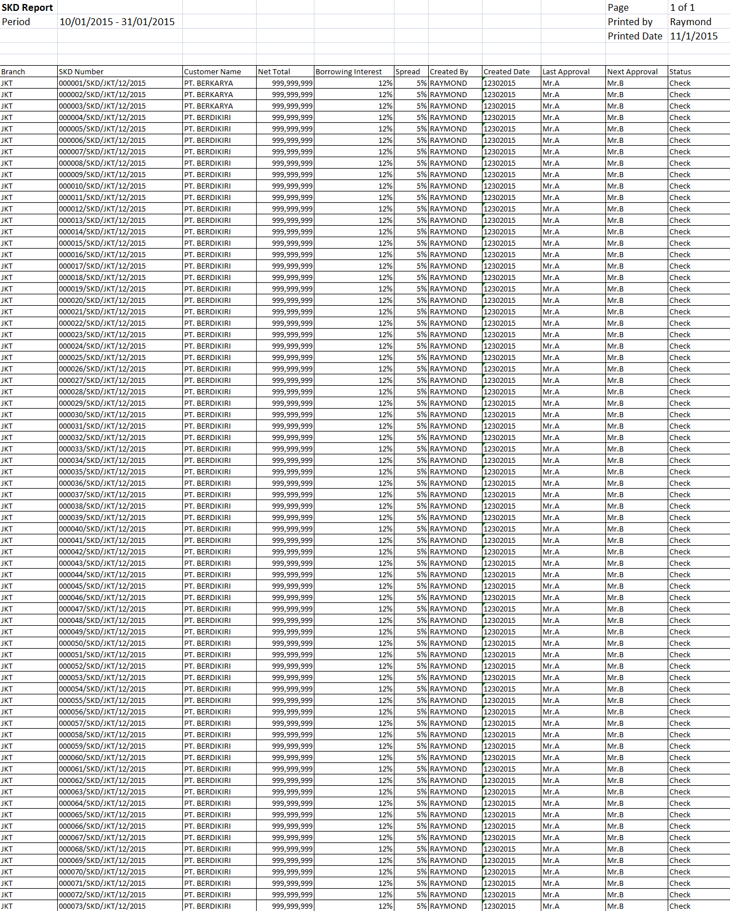

16

15

14

13

12

11

10

5

3

4

2

1

9

8

7

6

**PF.AB.2.1 SKD Form**

|  |  |  |  |  |
| --- | --- | --- | --- | --- |
| *No.* | *Content* | *Description* | *Source* | *Remarks* |
| 1 | Form Title | OPERATING LEASE BOARD OF DIRECTOR APPROVAL |  |  |
| 2 | Product | Operating Lease |  |  |
| 3 | Number | SKD Number | *Tb\_MKT\_SKD.SKDNo* |  |
| 4 | Customer Name | Customer Name | *Customer.CustomerName* | *Where*  *Tb\_MKT\_SKD.IdOPLQuotation = OPLQuotation.IdOPLQuotation*  *And*  *OPLQuotation.IdOPLCalculation = OPLCalculation.IdOPLCalculation And*  *OPLCalculation.IdCustomer = Customer.IdCustomer* |
| 5 | Group | Group | *Customer.Group* |  |
| 6 | Address | Address | *Customer.Address* |  |
| 7 | Date | SKD Date | *Tb\_MKT\_SKD.SKDDate* | *Format: ”MM/dd/YYYY”* |
| 8 | Type of Cars | Model Name Unit | *Product.ModelName* | *Where*  *Tb\_MKT\_SKD.IdProduct = Product. IdProduct* |
| 9 | New/Used | New/Used | *OPLCalculation.LeaseCategory* | *Where*  *Tb\_MKT\_SKD.IdOPLQuotation = OPLQuotation.IdOPLQuotation*  *And*  *OPLQuotation.IdOPLCalculation = OPLCalculation.IdOPLCalculation* |
| 10 | Accessories/Carroserrie | Model Name Accessories/Carroserrie | *Tb\_MKT\_SKD\_Dtl.Name* |  |
| 11 | Year | Model Year | *Product.ModelYear* | *Where*  *Tb\_MKT\_SKD.IdOPLQuotation = OPLQuotation.IdOPLQuotation*  *And*  *OPLQuotation.IdOPLCalculation = OPLCalculation.IdOPLCalculation*  *And*  *OPLCalculation.IdProduct = Product. IdProduct* |
| 12 | Supplier Name | Supplier Name | *Supplier.SupplierName* | *Where*  *Tb\_MKT\_SKD.IdSupplier = Supplier. IdSupplier* |
| 13 | Qty | Qty | *Tb\_MKT\_SKD\_Dtl.Qty* |  |
| 14 | Unit Price | Unit Price Unit | *CashflowSummary.ProductPrice* | *Where*  *Tb\_MKT\_SKD.IdOPLQuotation = OPLQuotation.IdOPLQuotation*  *And*  *OPLQuotation.IdOPLCalculation = OPLCalculation.IdOPLCalculation And*  *CashflowSummary.IdOPLCalculation = OPLCalculation.IdOPLCalculation* |
| 15 | Unit Price Accessories/Carroserrie | Unit Price Accessories/Carroserrie | *Tb\_MKT\_SKD\_Dtl.Price* |  |
| 16 | Total Price Unit/Accessories/Carrosserie | Total Price Unit/Accessories/Carrosserie |  | *Formula:*  *Qty x Unit Price Unit/Accessories/Carrosserie* |
| 17 | Total Cost of Product | Total Cost of Product |  | *Formula:*  *Total Price Unit + Accessories + Carrosserie* |
| 18 | COMPENSATION VAT IN OF “UNIT” | VAT Restitution “Unit” | *OPLCalculation.VATRestitutionUnit* |  |
| 19 | COMPENSATION VAT IN OF “CARROSSERIE” | VAT Restitution “Carrosserie” | *OPLCalculation.VATRestitutionCarrosserie* |  |
| 20 | COMPENSATION VAT IN OF “ACCESSORIES” | VAT Restitution “Accessories” | *OPLCalculation.VATRestitutionAccessories* |  |
| 21 | Total Compensation VAT IN of Product | Total Compensation VAT In of Product |  | *Formula:*  *Total COMPENSATION VAT IN OF “UNIT” + Total COMPENSATION VAT IN OF “ACCESSORIES” + Total COMPENSATION VAT IN OF “CARROSSERIE”* |
| 22 | Total Net Investment | Total Net Investment |  | *Formula:*  *Total Cost of Product - Total Compensation VAT IN of Product* |
| 23 | *n* unit | Qty | *Tb\_MKT\_SKD\_Dtl.Qty* |  |
| 24 | Net Investment | Total Net Investment |  | *Formula:*  *Total Cost of Product - Total Compensation VAT IN of Product* |
| 25 | Residual Value (% x unit price) | Residual Value (% x unit price) | *CashflowSummary.ResidualValuePercent* | *Where*  *Tb\_MKT\_SKD.IdOPLQuotation = OPLQuotation.IdOPLQuotation*  *And*  *OPLQuotation.IdOPLCalculation = OPLCalculation.IdOPLCalculation And*  *OPLCalculation.IdCashflowSummary =*  *CashflowSummary.IdCashflowSummary*  *Formula:*  *Residual Value / Total Net investment* |
| 26 | Residual Value | Residual Value | *CashflowSummary.ResidualValueAmount* | *Where*  *Tb\_MKT\_SKD.IdOPLQuotation = OPLQuotation.IdOPLQuotation*  *And*  *OPLQuotation.IdOPLCalculation = OPLCalculation.IdOPLCalculation And*  *OPLCalculation.IdCashflowSummary = CashflowSummary.IdCashflowSummary*  *Formula:*  *Residual Value Amount x Qty* |
| 27 | Lease term | Lease Term | *OPLCalculation.LeasePeriodPlan* | *Where*  *Tb\_MKT\_SKD.IdOPLQuotation = OPLQuotation.IdOPLQuotation*  *And*  *OPLQuotation.IdOPLCalculation = OPLCalculation.IdOPLCalculation* |
| 28 | Monthly Operating Lease | Monthly Operating Lease | *CashflowSummary.MonthlyInstallmentAmount* | *Where*  *Tb\_MKT\_SKD.IdOPLQuotation = OPLQuotation.IdOPLQuotation*  *And*  *OPLQuotation.IdOPLCalculation = OPLCalculation.IdOPLCalculation*  *And*  *CashflowSummary.IdOPLCalculation = OPLCalculation.IdOPLCalculation*  *Formula :*  *Monthly Installment Amount x Qty* |
| 29 | VAT 10% (+) | VAT 10% (+) |  | *10% x Monthly Operating Lease* |
| 30 | Billing | Billing |  | *Monthly Operating Lease + VAT 10%* |
| 31 | Witholding Tax Art 23 2% | Witholding Tax Art 23 2% |  | *2% x Monthly Operating Lease* |
| 32 | Net Payment | Net Payment |  | *Billing - Witholding Tax Art 23 2%* |
| 33 | *n* month | *n* month | *OPLCalculation.LeasePeriodPlan* | *Where*  *Tb\_MKT\_SKD.IdOPLQuotation = OPLQuotation.IdOPLQuotation*  *And*  *OPLQuotation.IdOPLCalculation = OPLCalculation.IdOPLCalculation* |
| 34 | Installment Income | Installment Income | *CashflowSummary.MonthlyInstallmentAmount \* OPLCalculation.LeasePeriodPlan* | *Where*  *Tb\_MKT\_SKD.IdOPLQuotation = OPLQuotation.IdOPLQuotation*  *And*  *OPLQuotation.IdOPLCalculation = OPLCalculation.IdOPLCalculation*  *And*  *CashflowSummary.IdOPLCalculation = OPLCalculation.IdOPLCalculation*  *Where*  *Tb\_MKT\_SKD.IdOPLQuotation = OPLQuotation.IdOPLQuotation*  *And*  *OPLQuotation.IdOPLCalculation = OPLCalculation.IdOPLCalculation* |
| 35 | Insurance Income | Insurance Income | *CashflowSummary.InsurranceCommisionAmount* | *Where*  *Tb\_MKT\_SKD.IdOPLQuotation = OPLQuotation.IdOPLQuotation*  *And*  *OPLQuotation.IdOPLCalculation = OPLCalculation.IdOPLCalculation*  *And*  *CashflowSummary.IdOPLCalculation = OPLCalculation.IdOPLCalculation* |
| 36 | KTB Discount Direct to DSF | KTB Discount Direct to DSF | *CashflowSummary. ATPMDiscount* | *Where*  *Tb\_MKT\_SKD.IdOPLQuotation = OPLQuotation.IdOPLQuotation*  *And*  *OPLQuotation.IdOPLCalculation = OPLCalculation.IdOPLCalculation*  *And*  *CashflowSummary.IdOPLCalculation = OPLCalculation.IdOPLCalculation* |
| 37 | Total Lease Income | Total Lease Income |  | *Formula:*  *Installment Income + Insurrance Income* |
| 38 | Product Price | Product Price | *CashflowSummary.ProductPrice* | *Where*  *Tb\_MKT\_SKD.IdOPLQuotation = OPLQuotation.IdOPLQuotation*  *And*  *OPLQuotation.IdOPLCalculation = OPLCalculation.IdOPLCalculation*  *And*  *CashflowSummary.IdOPLCalculation = OPLCalculation.IdOPLCalculation* |
| 39 | Residual Value | Residual Value | *CashflowSummary.ResidualValueAmount* | *Where*  *Tb\_MKT\_SKD.IdOPLQuotation = OPLQuotation.IdOPLQuotation*  *And*  *OPLQuotation.IdOPLCalculation = OPLCalculation.IdOPLCalculation*  *And*  *CashflowSummary.IdOPLCalculation = OPLCalculation.IdOPLCalculation* |
| 40 | Registration | Registration | *CashflowSummary.RegistrationValueAmount* | *Where*  *Tb\_MKT\_SKD.IdOPLQuotation = OPLQuotation.IdOPLQuotation*  *And*  *OPLQuotation.IdOPLCalculation = OPLCalculation.IdOPLCalculation*  *And*  *CashflowSummary.IdOPLCalculation = OPLCalculation.IdOPLCalculation* |
| 41 | Maintenance | Maintenance | *CashflowSummary.TotalMaintenanceAmount* | *Where*  *Tb\_MKT\_SKD.IdOPLQuotation = OPLQuotation.IdOPLQuotation*  *And*  *OPLQuotation.IdOPLCalculation = OPLCalculation.IdOPLCalculation*  *And*  *CashflowSummary.IdOPLCalculation = OPLCalculation.IdOPLCalculation* |
| 42 | Replacement | Replacement | *CashflowSummary.ReplacementCarAmount \* OPLCalculation.LeasePeriodPlan* | *Where*  *Tb\_MKT\_SKD.IdOPLQuotation = OPLQuotation.IdOPLQuotation*  *And*  *OPLQuotation.IdOPLCalculation = OPLCalculation.IdOPLCalculation*  *And*  *CashflowSummary.IdOPLCalculation = OPLCalculation.IdOPLCalculation*  *Where*  *Tb\_MKT\_SKD.IdOPLQuotation = OPLQuotation.IdOPLQuotation*  *And*  *OPLQuotation.IdOPLCalculation = OPLCalculation.IdOPLCalculation*  *And*  *CashflowSummary.IdOPLCalculation = OPLCalculation.IdOPLCalculation*  *Formula:*  *CashflowSummary.ReplacementCarAmount \* OPLCalculation.LeasePeriodPlan \* Qty* |
| 43 | Insurance Cost | Insurance Cost | *CashflowSummary.TotalGrossPremium + Rp 20.000* | *Where*  *Tb\_MKT\_SKD.IdOPLQuotation = OPLQuotation.IdOPLQuotation*  *And*  *OPLQuotation.IdOPLCalculation = OPLCalculation.IdOPLCalculation*  *And*  *CashflowSummary.IdOPLCalculation = OPLCalculation.IdOPLCalculation* |
| 44 | Mediator Fee | Mediator Fee | *CashflowSummary.MediatorFeeAmount* | *Where*  *Tb\_MKT\_SKD.IdOPLQuotation = OPLQuotation.IdOPLQuotation*  *And*  *OPLQuotation.IdOPLCalculation = OPLCalculation.IdOPLCalculation And*  *CashflowSummary.IdOPLCalculation = OPLCalculation.IdOPLCalculation* |
| 45 | Mobilization | Mobilization | *CashflowSummary.MobilizationFeeAmount* | *Where*  *Tb\_MKT\_SKD.IdOPLQuotation = OPLQuotation.IdOPLQuotation*  *And*  *OPLQuotation.IdOPLCalculation = OPLCalculation.IdOPLCalculation And*  *CashflowSummary.IdOPLCalculation = OPLCalculation.IdOPLCalculation* |
| 46 | DeMobilization | DeMobilization | *CashflowSummary.DeMobilizationFeeAmount* | *Where*  *Tb\_MKT\_SKD.IdOPLQuotation = OPLQuotation.IdOPLQuotation*  *And*  *OPLQuotation.IdOPLCalculation = OPLCalculation.IdOPLCalculation And*  *CashflowSummary.IdOPLCalculation = OPLCalculation.IdOPLCalculation* |
| 47 | Interest Cost | Interest Cost | *CashflowSummary.InterestExpense* | *Where*  *Tb\_MKT\_SKD.IdOPLQuotation = OPLQuotation.IdOPLQuotation*  *And*  *OPLQuotation.IdOPLCalculation = OPLCalculation.IdOPLCalculation*  *And*  *CashflowSummary.IdOPLCalculation = OPLCalculation.IdOPLCalculation* |
| 48 | Term of Payment Cost | Term of Payment Cost | *CashflowSummary.TermPaymentDays \* (CashflowSummary.ProductPriceTotal + CashflowSummary.AccesoriesPriceTotal + CashflowSummary.CarroserriePriceTotal) \* (CashflowSummary.BorrowingFlatPercent / 100) / 360* | *Where*  *Tb\_MKT\_SKD.IdOPLQuotation = OPLQuotation.IdOPLQuotation*  *And*  *OPLQuotation.IdOPLCalculation = OPLCalculation.IdOPLCalculation And*  *CashflowSummary.IdOPLCalculation = OPLCalculation.IdOPLCalculation*  *Where*  *Tb\_MKT\_SKD.IdOPLQuotation = OPLQuotation.IdOPLQuotation*  *And*  *OPLQuotation.IdOPLCalculation = OPLCalculation.IdOPLCalculation And*  *CashflowSummary.IdOPLCalculation = OPLCalculation.IdOPLCalculation* |
| 49 | Interest Cost before BAST | Interest Cost before BAST | *CashflowSummary.InterestExpenseBAST* | *Where*  *Tb\_MKT\_SKD.IdOPLQuotation = OPLQuotation.IdOPLQuotation*  *And*  *OPLQuotation.IdOPLCalculation = OPLCalculation.IdOPLCalculation*  *And*  *CashflowSummary.IdOPLCalculation = OPLCalculation.IdOPLCalculation* |
| 50 | Total Lease Cost | Total Lease Cost |  | *Formula:*  *Product Price+Residual Value+Registration+Maintenance+Replacement+Insurance Cost+Mediator Fee+Mobilization+DeMobilization+Interest Cost+Term of Payment Cost+Interest Cost before BAST* |
| 51 | Income – Cost | Income – Cost |  | *Formula :*  *Total Lease Income – Total Lease Cost* |
| 52 | Vat In “UNIT” | VAT Restitution “Unit” | *OPLCalculation.VATRestitutionUnit* |  |
| 53 | Vat In “ACCESSORIES” | VAT Restitution “Accessories” | *OPLCalculation.VATRestitutionAccessories* |  |
| 54 | Vat In “CARROSSERIE” | VAT Restitution “Carrosserie” | *OPLCalculation.VATRestitutionCarrosserie* |  |
| 55 | Vat In Maintenance | VAT Restitution Maintenance | *OPLCalculation.VATRestitutionMaintenance* |  |
| 56 | Total Compensation | Total Compensation |  | *Formula:*  *Vat In “UNIT” + Vat In “ACCESSORIES” + Vat In “CARROSSSERIE” + Vat In Maintenance* |
| 57 | Total Profit After Compensation | Total Profit After Compensation |  | *Formula:*  *(Income – Cost) + Total Compensation* |
| 58 | Landing Rate | Landing Rate | *CashflowSummary.PrimeEffectivePercent* | *Where*  *Tb\_MKT\_SKD.IdOPLQuotation = OPLQuotation.IdOPLQuotation*  *And*  *OPLQuotation.IdOPLCalculation = OPLCalculation.IdOPLCalculation And*  *CashflowSummary.IdOPLCalculation = OPLCalculation.IdOPLCalculation* |
| 59 | Borrowing Rate | Borrowing Interest | *CashflowSummary.BorrowingEffectivePercent* | *Where*  *Tb\_MKT\_SKD.IdOPLQuotation = OPLQuotation.IdOPLQuotation*  *And*  *OPLQuotation.IdOPLCalculation = OPLCalculation.IdOPLCalculation And*  *CashflowSummary.IdOPLCalculation = OPLCalculation.IdOPLCalculation* |
| 60 | Spread Rate | Spread Rate | *CashflowSummary.SpreadEffectivePercent* | *Where*  *Tb\_MKT\_SKD.IdOPLQuotation = OPLQuotation.IdOPLQuotation*  *And*  *OPLQuotation.IdOPLCalculation = OPLCalculation.IdOPLCalculation And*  *CashflowSummary.IdOPLCalculation = OPLCalculation.IdOPLCalculation* |
| 61 | IRR (without compensation Vat In) | IRR (without compensation Vat In) | *CashflowSummary.IRRwithoutVATIN* | *Where*  *Tb\_MKT\_SKD.IdOPLQuotation = OPLQuotation.IdOPLQuotation*  *And*  *OPLQuotation.IdOPLCalculation = OPLCalculation.IdOPLCalculation And*  *CashflowSummary.IdOPLCalculation = OPLCalculation.IdOPLCalculation* |
| 62 | IRR (with compensation Vat In) | IRR (with compensation Vat In) | *CashflowSummary. IRRwithVATIN* | *Where*  *Tb\_MKT\_SKD.IdOPLQuotation = OPLQuotation.IdOPLQuotation*  *And*  *OPLQuotation.IdOPLCalculation = OPLCalculation.IdOPLCalculation And*  *CashflowSummary.IdOPLCalculation = OPLCalculation.IdOPLCalculation* |
| 63 | Payment Type | Payment Type | *CashflowSummary.PaymentType* | *Where*  *Tb\_MKT\_SKD.IdOPLQuotation = OPLQuotation.IdOPLQuotation*  *And*  *OPLQuotation.IdOPLCalculation = OPLCalculation.IdOPLCalculation And*  *CashflowSummary.IdOPLCalculation = OPLCalculation.IdOPLCalculation* |
| 64 | Payment Mode | Payment Mode | *Tb\_MKT\_SKD.PaymentMode* |  |
| 65 | Note | Note | *Tb\_MKT\_SKD.Note* |  |
| 66 | Approval | Approval |  | *Refer to FC.C.1.1 System Setting – Setting Approval Path*   * *Prepared By : Marketing Officer* * *Acknowledged By/ Approved By (from left to right) : Head of Branch/ Head of Department, Regional Manager, Advisor, Director, President Director, Shareholder’s Meeting* |
| 67 | Keterangan | SKD O/S Investment |  |  |
| 68 | Customer Name | Customer Name | *Customer.CustomerName* |  |
| 69 | Harga | Total Net Investment |  | *Formula :*  *= Total Net Investment* |
| 70 | RV | Residual Value | *CashflowSummary.ResidualValueAmount* | *Where*  *Tb\_MKT\_SKD.IdOPLQuotation = OPLQuotation.IdOPLQuotation*  *And*  *OPLQuotation.IdOPLCalculation = OPLCalculation.IdOPLCalculation And*  *CashflowSummary.IdOPLCalculation = OPLCalculation.IdOPLCalculation* |
| 71 | Net | Net Investment |  | *Formula :*  *Total Net Investment – Residual Value Amount* |

**PF.AB.2.1 SKD Form**

17

2

6

5

4

3

1



22

21

15

16

9

8

10

53

71

70

69

68

67

65

33

23

19

20

18

14

13

12

11

7

36

52

51

50

49

48

47

46

45

44

43

42

41

40

39

38

37

35

34

64

63

60

59

58

32

30

31

29

28

27

26

25

24

****

57

56

55

54

66

61

62

* 1. Entity Relationship Diagram

